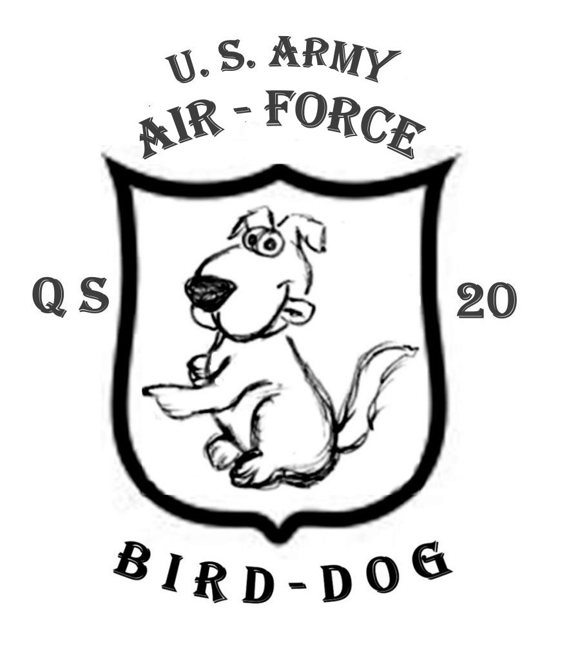

STORY LINE of QS - 20
an Air Sea Rescue Vessel WWII

TIME LINE

Aug 42: D-DAY Guadalcanal
Feb 43: Secured
Sep 43: QS 20 launched
Nov 43: Henderson Field (Guadalcanal) fully operational for Heavy-Medium-Light bombers allowing AAF to move up from Espirito Santo
Jan 44: QS-20 Begins transit to West Coast
Mar 44: Arrive at Honolulu
Apr 44: Arrive at Guadalcanal
May 44: Arrive at Hollandia
Oct 44: Philippines Secured

PLACES

Florida
Fort MacArthur
San Pedro, California
Honolulu, Oahu, Territory of Hawaii
Sand Island
Pali HighwayKailua
Keehi
Hickam Field
Ellice Islands
Gaudalcanal
Aitape
Wewak
Hollandia
Biak
Wadke
Ceram
Moritai

NAMES

Thomas (Thom) Larson: Skipper of QS20
Mr. Henry (Hank): Original skipper
Lee Robb: Lieutenant Colonel
Paul Cargill: Bird Colonel
Doe: General
CG skipper of FS-166 CWO
Jack Sharpe “Smilin' Jack: Sergeant 1st Class
Lamar Cheuter “Shooter”: Tech Sergeant

MISCELLANIOUS

US Army FS2A 112' Ambulance
US Army Transportation Corps (Harbor Craft) (Ship & Gun Crew)
USCG FS 166 tow to Hawaii
15th AAF
BOLERO Code name for concentrating on European needs first
Dumbo PBY Catalina amphibian rescue aircraft
“BIRD-DOG” Call name for QS 20

“Bolero Project”

Diplomatic commitments by the United States to the “Bolero Project” were made with European allies prior to the Japanese attack on Pearl Harbor on December 7, 1941; the Allies agreed that logistics and manpower were needed to support Britain and her allies in their attempt to slow the German incursions across Europe and North Africa.
Many Americans felt that after the bombing of Pearl Harbor the Pacific was our war and should have been fought more aggressively from the beginning and not put on the back burner while particular goals were made in Europe.
Reports from the Pacific chronicled one disaster after another. The first favorable news came in April, 1942: Lt/Col. Doolittle’s B-25 bombing raid on Japan proper. Though it caused little damage, the raid proved that the Japanese could no longer feel safe and secure in their home islands and required them to fortify with manpower and equipment to defend their homeland. The raid was a monstrous morale booster back home in the USA.
Lacking air fields to base long range bombers to blunt the Japanese advances in the Pacific, the task fell upon the US Navy and her aircraft carrier fleet to repulse the enemy.
The first major turning point of the war in the Pacific was the “Battle of the Coral Sea” in early May of 1942. Though not what could be considered a decisive victory for the Allies, had that battle been lost the Aussies and Kiwi’s might have had to learn to speak Japanese.
One month later in early June 1942 a Japanese Invasion Fleet at the “Battle of Midway” was successfully repulsed, with heavy losses on both sides.
Three months later other major incidents took place that turned the tide of the war in the Pacific: two invasions, one at Guadalcanal and the other 25 miles across the Sealark Channel at Tulagi. These islands were in the forward thrust of the Japanese advances. The Japanese had started construction of an airfield that was within bomber range of the Allied supply routes to Australia. Success did not come easy; lessons were learned in those battles that set the modus operandi for future operations in the island hopping achievements in the Pacific.
In addition to battling a fanatical driven enemy our troops had to contend with malaria, dysentery and jungle rot (a fungi type of infection caused by the humidity, lack of nutritional diet and proper hygiene. If left untreated it covered massive areas with open sores under the arms and between the legs, it itched and stunk like hell, not unlike a badly infected case of poison Oak or Ivy). There were too many other illnesses to name that took an astounding toll amongst the GI’s.
Ten times the numbers of American warriors were lost due to tropical illnesses than were wounded in combat with the enemy.

QS - 20
AIR/SEA/RESCUE

This is a story of a specifically designed vessel for the Quartermaster Corps, Air Sea Rescue Service, which later was assigned to the US Army Air Corps and then the USAAF. It was a high speed vessel patterned along the concept of what Britain’s RAF and German Luftwaffe used for rescuing downed air crewmen in the English Channel during their cross channel bombings of World War II, built similarly to our own naval Patrol Torpedo Boats.
QS-20 was launched in October, 1943 at a boatyard in Florida and towed to Los Angeles through the Panama Canal, where she waited for a series of Pacific storms to abate before assigning a civilian Civil Service crew to continue her tow to the South Pacific.
At first they loaded the earlier smaller models as deck cargo aboard ships but it became a problem to off-load the boats without heavy lift cranes in the forward combat areas; and deck spaces at the time were at a premium.
Construction of the 63 foot boats was curtailed when they were found to be too small and unsafe to operate in Air-Sea-Rescue operations in open seas, but they went on to be useful as coastal, fast, small medical evacuation transports.
The new larger boats had a limited fuel range of less than 600 miles and only then at a greatly reduced speed, while causing wear and tear on both the engines and hulls. Towing them to the Pacific was determined to be a more practical method.
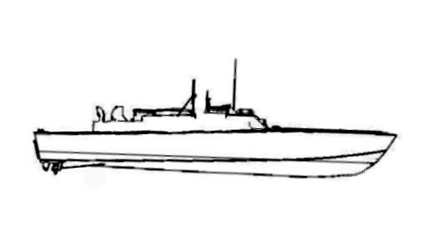
Her silhouette was very much like that of the US Navy’s famed Patrol

Torpedo Boats (PT’s) but without torpedo tubes. She was originally designated as an Army Patrol/Rescue Boat. She was later reclassified as a QS boat; 85 feet OAL with a beam of 20 feet. According to the builder’s specifications of this experimental boat, venturing from tradition she was built without a normal heavy keel for a backbone and relied on four large hardwood longitudinal stringers for both engine beds and fuel tank supports along with well placed stout bulkheads and sawn frames. She was diagonally stripped cross-planked with approximately half-inch, five-ply Wellwood marine plywood. QS-20 had two Allison “M” (marinized) V-12 cylinder aircraft engines (an early General Motors Development) rated at 1,300 horsepower each, using 100 octane gasoline.
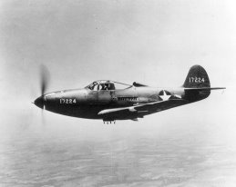
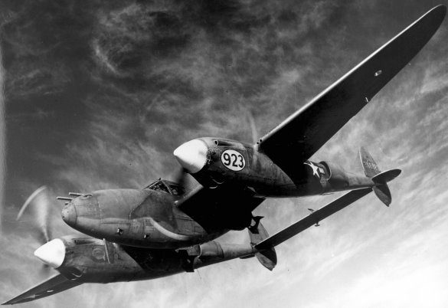
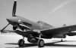
These engines were very similar to the ones used in the
P-39 “Airacobra” P-38 “Lightening” P-40 “Hawks” pursuit planes.
It is reported that some of her later QS sisters being built in other yards had two and sometimes three Packard V-12’s, an up-graded Allison type turbo-charged engine, two in-line with the third in a reversed configuration (shaft coupled to a “V” drive, then passing under the engine to the propeller). The QS boat with her sealed coolant Allison engines was designed to get up and plane near 20 knots with a top speed of over 30 knots with normal two-thirds load and fuel. She also had water-jacketed exhaust manifolds and heat exchangers for cooling the sealed coolant, transmission and engine oil, and was also equipped with marine clutches and gear boxes.
Her civilian Army Transportation Service delivery crew consisted of 10 men: a skipper, mate, three deckhands, an engineer, three oilers in the engine room, and a cook. The quarters were cramped, but comfortable once a crewman got used to his own little niche, but certainly not intended for extremely long periods.
This story also follows the tenure aboard QS-20 of Thomas Larson who was originally from the Pacific North-West. After having escaped the toils and hard life of a large family of poor Danish dirt farmers, he began his sea life aboard steam schooner lumber ships of Washington’s Puget Sound “Scandahoovian” navy as a boy of 15. Older co-workers at first referred to him as “Tommy Boy” until he let them know that he only wanted to be called by his chosen name “Thom”... “And spell it with an “h” please, 'cause that's how my Mom named me!”
Two years of hard work matured him into a robust and muscular young man of 180 pounds on a 6’2” frame, making him a prime candidate to man-handle rogue logs bound for the sawmills. Eventually his labors led to his skippering of a snag tug, a job very similar to a cowboy rounding up stray cattle to form a herd. Of course with a last name of “Larson” and sprouting a healthy crop of blond hair, he fit in well with the Swedes. Thom quickly learned the ropes and eventually was assigned to a ship as a bos’n able-seaman heading to San Pedro with a full load of lumber some months before Pearl Harbor was bombed.
A call for merchant seamen to sail aboard vessels from east coast ports to Europe (with assurances of great pay) seemed to be a promise of adventure and patriotism that Thom couldn’t pass up.
After two years of criss-crossing the Atlantic and enduring the cold and icy conditions, Thom was encouraged to upgrade to a 2nd mate's ticket. Hearing of a need for deck mates on the West Coast and having had his fill of the East Coast, he decided it was time to change his luck. In addition to the weather, he also faced the dilemma of being forced into a committed relationship with a lady who (while undeniably a sorceress under the sheets) constantly harped on him to quit sailing and settle down to a life as a house-husband. Not to mention the fact that they were fast using up his savings to party every night. After less than ten minutes of consideration, Thom wisely decided to head back to the West Coast hoping to sign on a ship going to the Pacific.
Word of mouth circulated that the Army was seeking experienced seamen to sign one-year contracts for duty in the Southwest Pacific. Thom traveled to the personnel office of the Army Transport Service at Pier 43 in Wilmington, California. While awaiting his turn at the counter, two very angry men came in arguing in loud voices and seemed about to settle things with their fists. An Army Captain, whom Thom took to be the Transportation Officer or Port Captain, herded them into his office, but even through the closed door Thom could hear the heated argument continuing.
After filling out a list of his sea time and recent positions aboard ships, an Army clerk at the counter took Thom’s application, perused it, and then asked him to return after the morning coffee break, indicating that he just might have something for him.
About an hour later when he returned the clerk asked, “Would you be interested in signing on as a delivery skipper replacement on a small vessel leaving in a couple of days?”
Thom told him he hadn’t made any plans as he just got in from the East Coast and was hoping (at best) to sign up for a bunk as “Cadre” (available but unassigned). He couldn't believe his luck and didn’t even ask ‘where to or for how long’, he just said, “Where do I sign?”
But, maybe he should have asked questions because that’s how he became involved with this tiny QS boat that was to be such an integral part of his future.
After his interview with the Port Captain, phone calls were made to confirm his records then he was provided transportation to the Public Health facilities at the Post Office in San Pedro for a preliminary physical. On his return to the ATS personnel office the G.I. clerk arranged transportation to the Catalina Island Ferry Dock in Wilmington.
The driver, upon delivering Thom to the slip, pointed to a ramp that led down
to some floats. It was low tide and not seeing any ship, Thom turned to the driver and asked, “Where’s the ship?”
The driver said, “Look at the bottom of the ramp,” then gave Thom a “thumbs up” and hastily drove off.
He wrestled his duffel bag down a steep ramp, then along a narrow finger float to a small sleek-looking speed boat that appeared to be about 100 feet long. He hailed a man working on deck and asked if the skipper was aboard. The man halted his chores and went to an opening in the bridge area where he called down for the Captain.
Thom feared he had made a big mistake when he saw that the man who came on deck was one of the two men who had been arguing in the personnel office.
Being tired and in no mood to let this guy dump on him like he saw him doing to the guy in the office, Thom was about to turn and leave the float when, to his surprise, the man jumped down beside him and reached out to shake Thom’s hand.
With a wide grin, he welcomed him to board his boat. “Hi! I’m the skipper. My name’s Phil Henry but everyone calls me Hank… and you must be Thomas. I went over your résumé in the office. Welcome aboard! By the way, we’ll be getting underway for a short run as soon as you can stow your gear. We just got out of the shipyard to correct a vibration problem.”
For a few moments Thom hesitated while sizing up the tall, lanky, bushy haired and well-tanned figure in front of him. He glanced over at the diminutive size of the boat and wondered if he really wanted to get involved. “May I ask a question?” He continued on without waiting for a reply, “Why the argument in the Captains office?”
Hank said, “That SOB hired on as the new skipper and originally agreed to stand six on and six off watches while under tow, with the understanding that he and the mate would be accountable for each of their own watches but it would be at their own leisure (awake, on deck and on call). The deckhands would stand a regular four on eight off watch routine, ready by the helm while standing lookout duty. At the last minute he decided he wanted overtime pay and wouldn’t stand the long watches without the extra pay. I think it was just an excuse for him to quit the boat.”
Thom paused, thinking of what he might be getting into…then said to himself, “Aw, what the hell!” and heaved his duffel bag aboard the boat.
After being introduced to the Mate and crew and going over what the watch assignments were and with whom, Thom was led below and assigned a bunk in a tight little compartment. He was still in the process of unpacking when he heard the roar of the engines starting up. He went topside and assisted taking in the mooring lines which the crew stowed below in the after lazarette while Thom went to the bridge with the skipper. With an almost ear-splitting roar the boat moved into the channel at a very slow speed so as to not create a wake to jostle small craft along the docks. On the way to the outer channel Hank pointed out buoy locations on a mimeographed page while pointing out major terminals, shipyards and points of interest so Thom could get the lay of the area.
Once outside the main channel and cruising parallel to the breakwater at the outer harbor, Hank opened up the throttles and then retarded one engine while maxing out the other engine; he repeated this maneuver several times exchanging the procedure from one engine to the other.
The engineer came topside and gave Hank an OK sign, reporting no vibrations and no leaks in the stuffing boxes.
Hank offered Thom the helm, then went below and soon returned to the bridge giving Thom the high sign that everything was OK. Thom started to turn over the helm to Hank but the skipper said that he, Thom, should dock the boat at the slip. After entering the tight busy cove filled with small tugs and personnel boats Thom, relying on his experiences during his snag tug days, maneuvered a turn around, and backed astern into the slip using mainly the thrust of the engines.
The lines were secured to the dock and after the engines were shut down Hank turned to Thom, slapped him on the back and said, “Good job, son. My congratulations! You just earned my recommendations as the new skipper. Now, maybe I can get back home to Florida.” They took off for the Transportation office and finished completing their paperwork; Thom to sign a one year contract taking over responsibility of the QS 20 and Hank to fill out papers for his return to Florida. For the first time since he'd arrived on the west coast again Thom was excited...and damned if he didn't feel downright jazzed!
The next couple of days were hectic for the crew. To their dismay, all liberties were canceled and it seemed every waking hour was spent taking on stores and double-checking that the QS was ready for heavy seas. Only when news came down to make ready for sea did their spirits rise. At six o’clock in the morning Thom woke the crew by starting the engines and passing the word to grab their coffee and get busy. There'd be plenty of time for breakfast after they were hooked up for towing.
The morning was chilly and damp as they got under way up the main channel. Thom informed the crew that their tow was waiting at the outer harbor
and that he would give them the details later.

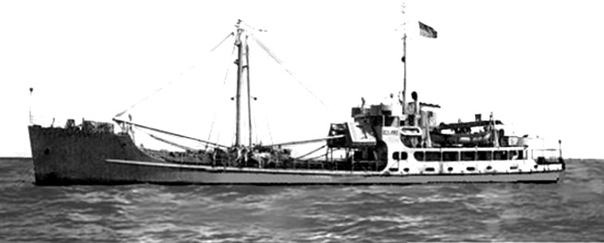
They approached a small modern looking two-hold freighter, called an FS boat. Barely making headway, the QS tossed them a heaving line that was attached to a mooring line which, in turn, was attached to a heavy twenty foot length of 5’’ diameter ‘cable-laid’ manila line shackled with two leads of wire-clamped bights, making up a bridle secured to the port and starboard forward bits on the bow of the boat. The FS deckhands attached their towing wire and started paying out. The QS secured their engines and were silently led out to sea through the anti-sub nets at Angles Gate, on their way to where-ever.
During breakfast the skipper informed the crew (as if they hadn’t already guessed) that they were on their way to Honolulu. A gentle westerly swell, a full belly and, per general consensus, time for a nap.
The QS, being towed by the FS, passed the West End of Catalina in the early afternoon at a speed of about seven knots. Occupying his time learning the boat, Thom went below into the steering compartment to check the rudder packing, slop in the tiller arms and for any slack in the steering cable. The Engineer was proud of his domain and showed Thom the essentials.
Around four in the afternoon the FS boat hoisted a signal flag that they were about to begin practice-firing their weapons. Thom decided to break out their small arms for a little target practice. The boat had two .30 caliber carbine rifles which he gave to the deck crew to plink around with while he and the mate fired off their Colt .45 pistols.
Thom was on watch and was standing in the bridge helm area when suddenly he heard an outburst of yelling from amid-ship. “The mate’s been shot in the foot and he’s bleeding badly and in a hell of a lot of pain!”
Thom went back to check the wound. He cut off the shoe and ordered one of the crew to wrap a tourniquet below the injured man's knee, then apply pressure directly on the wound. When the pressure was applied the mate let out an agonizing scream and fell back in a dead faint.
Thom hurried below to the navigation area for the Aldis signal lamp and battery. On finding them, he returned to the bridge and started blinking to the FS boat of their problem. The FS boat immediately started shortening the tow line and at the same time lowering their 26 foot motor whale boat. The Coast Guard Coxs'n and his crew helped in transferring the mate, now secured in a Stokes Litter (a metal tubular frame with a chicken wire mesh molded in the shape of a body), to the whale boat and then to the FS boat.
About an hour later they brought the mate back on the whale boat and transferred him aboard the QS boat. A Coast Guard Warrant Officer, Captain of the FS boat, also came with the injured mate and said they weren’t able to control the bleeding and that some of the foot bones had been shattered. He suggested that the QS drop the towing bridal and return to San Pedro to seek emergency medical treatment for the injured man. Otherwise, there was the chance the mate might lose too much blood or become permanently disabled.
The FS boat's captain said that they would continue on their present West by South West course at 7 knots until 10 the next morning and after that would continue on at their normal cruising speed and course. He suggested that, with luck, Thom could get to San Pedro, off-load the injured mate and make it back out to rendezvous with the FS before they resumed normal cruising speed IF he didn’t run into any problems while in port. Otherwise Thom would have to stay in port until another tow could be arranged at a later date.
While approaching Point Fermin they cruised parallel to the breakwater. Thom, using the Aldis blinker lamp, raised the signal tower above the multi-storied main warehouse building at the entrance to the main channel, now being used by the Navy. He requested entrance past the ASW nets, explaining that they had a critically injured man and couldn’t stop the bleeding. The warehouse signalman suggested that QS-20 head for the old Navy Liberty Dock at 22nd street near Berth 57 after they made it past the entrance nets, and that the signal tower would call for an ambulance to meet them. Thom asked if the signal tower would also notify the Army Transportation office at Pier 43 in Wilmington of the problem.
Thom was not only determined to get help for the bleeding man, but also make it back out to meet his tow; so as the QS approached the ASW nets it was haul-assing full speed. The tug had just started moving the net towards the lighthouse when the QS neared. In a beautiful maneuver that was part luck and part skill the boat planed over the sagging side of the net (instead of through the proper opening) into the harbor without slowing her engines. The crew witnessing the event, were slack-jawed.
The QS slowed down on entering the basin. The loud roar of the engines reverberated against the row of warehouse walls with the liberty dock at the far end. So far there was no sign of an ambulance or flashing lights and apparently no room at the float with so many launches coming and going. Finally, Thom spotted a space at the wharf behind a freighter and maneuvered to put the QS’s stern towards the dock.
The mate was already strapped in the Stokes litter and was soon being lifted to the dock. Thom spotted an Army officer and asked him if he was sent by the Army. He answered that he had been on duty at Fort MacArthur, just up the road, when the call came in.
Throughout the entire emergency Thom was oblivious to another drama taking place on the boat. Now that the mate was being tended to, he gathered the crew see if he could get to the bottom of just what in hell happened. He vaguely remembered the engineer saying something about an accident...a terrible accident, but he'd been so involved in trying to stabilize the mate and at the same time navigating and operating the boat that he'd ignored it at the time. Now he was facing a completely shaken engineer who kept repeating, “It was an accident. I didn't mean to do it. It was an accident.”
Thom put his hand on the man's shoulder, “Calm down, man, explain yourself.”
The engineer looked up with tears in his eyes, “My pistol jammed and I couldn’t dislodge the cartridge. I hit the back of the slide with the butt of my hand and the gun discharged just as Roy walked by.”
Thom remembered seeing the engineer squatting alongside and trying to comfort the mate as they neared the harbor entrance, then hadn’t noticed him again.
Thom looked up as the ambulance finally arrived and nosed past the lookie-loos that had gathered on the dock around the litter. “Hold that thought Chief, I've got something I have to take care of before they haul Roy off to the hospital.”
The crew had gathered all the mate’s personal belongings, putting what they could in his suitcase and the rest into pillow cases, and Thom had them sent ashore with the litter. The Army officer from Fort MacArthur was standing by the litter taking notes and Thom climbed up on the dock to talk to him about the incident. While talking with the officer Thom noticed the engineer taking his belongings off the QS and putting them alongside the mate’s pile on the dock.
Thom hailed him, “Hey Chief, just what in hell do you think you're doing. I thought I said to cool it and wait for me to get back with you.”
With anguish shaking his voice the engineer replied, “I’ve got to stay with my friend. We sailed together before…he even talked me into taking this job…I did this to him and there is no way I can make the trip not knowing how this works out. Write it down in the log that I jumped ship...or put anything you want, but I can’t go with this on my conscience.”
Thom did his best to talk the engineer back aboard but the man was adamant in his desire to stay ashore with his old buddy. “Damn!” he thought to himself, “Now I'm without a mate and an engineer!” He then asked the Fort MacArthur Army Captain if he could handle the details ashore as a ship was standing by beyond the Channel Islands for the QS and crew to return to continue on with the tow. The Army Captain said he’d try to handle the paperwork.
It took the QS almost four hours to make port, another hour or so to off-load the mate and then four hours to power back to the original drop off point. QS-20 then continued on a West by Southwest course
A slight hint of daylight was breaking through and still Thom could see no sign of the FS boat. Scanning the horizon ahead with the binoculars showed no masts of their mother ship. Thom ordered a slight southerly change of course with a bump-up in engine turns. They had been on this heading for over an hour when one of the deckhands saw a tiny speck far ahead. As they drew nearer he could make out the profile of the FS boat and started blinking her. They eventually caught up to her and powered along side, shouting the details of their mad dash to port while they were assembling and transferring the towing rig and the start of paying it out.
The ten-day trip was boring and uneventful until they neared Oahu. Thom was the only surviving officer aboard now and, with the loss of the engineer, the senior oiler was acting as a temporary chief; things worked out surprisingly well. The crew volunteered to pitch in and cooperate; the deckhands and the three-man engine crew stood their four-on eight-off watches with orders to call Thom anytime if anything seemed just the slightest bit out of the ordinary. Hank, the previous skipper, had suggested that they fire up each engine for a few hours each day on alternate days to keep the batteries charged.
As the boat approached Oahu in the Molokai Channel a huge following sea developed, traveling along at a fair rate of speed with estimated swells of twenty feet. For a while the crew thought it was fun; something to chase the boredom. The huge swells would pick up the QS’s stern and they would surf down the steep wall, the weight of the tow-line helping to accelerate the pace. Then it got hairy; when picking up speed and traveling with the swell for quite a while they almost approached the FS boat. Suddenly they came to an abrupt standstill, sitting in the bottom of a trough, and were unable to see anything but the ocean about them. That was, until the tow-line pulled unexpectedly taut as the towing FS boat caught an ensuing swell. Their bow was jerked around like a yo-yo on a string, nearly knocking everyone off their feet.
The new acting chief started removing the propeller shaft clamps, a time-consuming job in calm waters; but with the boat going through the uncontrollable gyrations caused by the wave actions it seemed to take forever. Finally they got the engines on line and with power they could ease the sudden jerking to some extent... but couldn't seem to get their rhythm in sync with the FS boat. Blinking the FS boat, Thom requested that the FS drop the tow and allow them to head into Honolulu under their own power before the jerking tore the bow off the boat. The FS readily agreed.
While separating the towline two Army Air Force pursuit planes started low level buzzing as if attacking them. After five or so passes the FS boat hoisted several signal flags, the planes made one last pass then wiggled their wings and flew off. Thom was puzzled, but it reminded him to ask the Coast Guard skipper for the protocol on entering Honolulu. The skipper passed on the necessary information, which seemed to be a jumble of code flags and responses to any blinker challenges. Thom often wondered later if they would have been fired on or sunk trying to enter without that information.
After gaining entrance into the harbor the signal station atop the Aloha Tower blinked them, instructing them to proceed up the left channel and tie up to a wharf in the upper bay of Sand Island where an officer would show up directly. After blinking his thanks, Thom went in search of the wharf. The boat tied up and one of the crew found a faucet and hose under the dock. He turned the water on full blast and started hosing everyone on deck. Immediately some of the men began shedding their clothes and washing themselves down. The scene looked like a bunch of street kids playing at a fire hydrant. After ten days at sea this was the first fresh water they’d had to wash off the dirt and salt from the trip.
Thom grinned and shook his head, “Why don't some of you clowns grab yourselves a scrub brush and rinse off the deck and house while you're playing around. And, it wouldn't hurt to wash some of the stink and grime out of the fo'c's'le while you've got the chance.”
An Army ‘light’ Colonel was walking briskly along the mole when he saw the commotion and ventured onto the wharf. Thinking he was the officer that was to meet the boat, Thom called to the men to watch where they were pointing the water and invited him aboard.
Thom glanced at the silver oak leaf and crossed rifles on the Colonel's collar points. “It's odd to see an infantry man involved with an Army Transport vessel, Sir.”
“Hey,” the Colonel replied, “I just saw all the excitement with the water hose and came on the dock for a closer look.”
“The guys are just happy to get a fresh water shower. We just came in from the states. I thought you were the officer that was to meet us here.”
“My name’s Lee Robb, Lieutenant Colonel. I’m on my lunch break and I often walk on the mole to get some fresh air and to beef up my injured leg muscles. The walk clears out some of the morning cobwebs.”
Thom nodded, “When I saw the crossed rifles on your collar points I thought the army had finally realized the value to the infantry of boats like this.”
The Lt. Col. Looked at him quizzically, “What value is that?”
“Well,” Thom said, “like the Brits did in North Africa when they took the torpedo tubes off and turned them into high speed gun boats to ferry water and supplies and evacuate the wounded from the overrun elements of the Eighth Army along the Libyan and Egyptian coasts. What a heroic job they did.”
Thom was about to go on, when one of the crew informed him that a jeep had just pulled up on the dock and an officer was about to board the boat.
As the officer approached, Thom turned to him, “Welcome aboard sir, my name is Thomas Larson. I’m the skipper of QS-20.”
“ 1st Lt. Collard, good to meet you.”
Thom turned to the Colonel to introduce him; the two officers saluted and exchanged their protocols.
The Colonel then turned and shook Thom’s hand, “Time for me to be getting back. A pleasure to have met you, Larson.” He nodded at the other officer, “Lieutenant,” then departed the boat.
The 1st Lt. announced, “I’m instructed to tell you to have your men gather their personal belongings and put them together on the dock by 16:00. A bus or a truck will pick them up and take them to be fed and temporarily housed. You and your engineer are to remain aboard until a board of inquiry meets or you and the engineer give your depositions regarding the shooting back in San Pedro.”
“Do you know how the mate is doing?” Thom asked.
“Last I’ve heard he's fine.”
“We’re about out of fresh food. Will we be receiving any provisions?”
“Make out a short list and I’ll have it delivered when the bus picks up your crew.”
With the engineer's input, it only took a moment to make up the list. Thom handed it to the 1st Lt., who grabbed it and vacated the boat as if he had a hot date waiting.
The crew still had a few hours before they were to leave so Thom had them clean up the boat or at least make it more presentable. The galley was put in order, the bunks were stripped, sleeping quarters were tidied, and topside and below decks were washed down. The last thing for the day was saying their goodbyes. They brushed on the highlights of the trip over until it became repetitious. Finally, the bus came to pick up the crew; also bringing a couple of boxes with coffee, loaves of sliced bread and other food essentials from Thom's list. The crew loaded their gear on the army bus and took off.
With time on his hands and a hearing or deposition looming, Thom reviewed the log. While writing this account during the trip over, it was hard to believe how short and cryptic the daily entries were in the small makeshift logbook. There were only four or five short lines to sum up date and time, weather, courses, mileage, sea conditions along with other events of the day. However, it was to prove valuable at a later hearing.
Friday morning came and went and by late in the afternoon there was still no word from the Transportation office. Thom theorized that Friday afternoons must be the time when the officers and their office staffs do their weekly tidying up of agendas and prepare for the weekend (war or no war).
Thom told the Engineer he could take off at 16:00 for a little shore leave and that he would stay aboard. A little later in the afternoon a jeep pulled up at the dock and two officers got out and walked down to the boat. Thom recognized the Light Colonel, Robb, and with him was a full Bird.
“Good afternoon Captain. I mentioned to my boss about the Brits’ gun boats you were telling me about and he found it very interesting. This is Colonel Paul Cargill. I’d appreciate you telling him what you told me about the MGB’s and what they did.”
“It’s a pleasure to meet you Colonel Cargill, why don’t we go below it’s cooler down there.” They went below and settled themselves as comfortable as possible at the mess table.
Thom smiled, “I'm a bit surprised that someone shares my interest. As to those little Limey MGB’s, they were similar to this boat in many ways and earned a honorable stature with the troops in North Africa. I was 3rd Mate on a small, ex-United Fruit refrigerated ship in Britain; we were assigned an MGB escort for our passage in the Channel. Our escort knew where the mine fields were and they were also to provide us anti-aircraft defense as well as chasing off any hi-speed Kraut E-boats. During a nasty gale, and fearing for our little escort, the Captain decided to seek shelter behind a headland. The MGB tied up alongside and our skipper invited the crew aboard.” Thom grinned and said, “Hey! Don’t be afraid to stop me if you think I’m going into too much detail.”
The colonel smiled back, “Details are what I’m after. It’s just after 16:00, I’m on a break but I do have to call in. You wouldn’t happen to have a bottle of hard stuff aboard, would you?”
“Not a drop of anything. I wish we did have but we just got in from the mainland. I told my Engineer he could go ashore, so I have to stay with the boat for tonight.”
“What’s your choice of drink, Captain? I’m buying,” the bird Colonel said.
“If it’s good whiskey,” Thom said, “I’ll drink it as is. If it’s rot-gut you’d better put Ginger Ale or Coke on the list. I’ll spring for some sandwich makings if they’re available.”
The bird-colonel stood, “We’ll take your engineer ashore with us and drop him off and we'll be back in about an hour or so.”
After they left, Thom started up one engine to build up the batteries then found a canvas wind scoop. He took a 20 foot boat hook and with some line fashioned a mast to hang the scoop to capture the evening breezes and send them down into and through the forward fo'c’s’le hatch.
The damned radio had never worked properly since he came aboard, so he tinkered with it until he found a weak local station playing Hawaiian music. He then sat waiting….one hour…. then almost two hours and was about to call it a night when a jeep pulled up. The engineer came aboard pissed as hell. The Colonels had dropped him off and left him at the main gate on the mainland side of a wooden bridge on their way out. The sentry said he didn’t have the right ID or pass but after explaining the circumstances the guard was willing to let him go through...but warned him he might not convince the guards to let him re-enter. To add to his problems, the guard said it was a several mile hike to the nearest tavern. Discouraged, he decided to walk back to the boat. He was well into the hike back to the boat when the Colonel’s jeep stopped and offered him a ride.
The two Colonels and another fellow dressed in what appeared to be reddish brown two-piece hospital casuals with US Army MD embroidered on the chest, came aboard with their arms loaded with cardboard boxes and sacks filled with everything you could imagine; booze... good stuff...two long square cans (one of cheese and the other of ham) pretzels and, much to Thom's surprise, several bottles of Aussie beer.
“Thought we’d come and make a party of it…I hope you don’t mind? Our wives are really pissed for not taking them out to dinner tonight but we convinced 'em this 'conference' was vital to the war effort. I brought a friend along; he served a tour in England at the start of their war, and is interested in your story of the MGB’s.” Colonel Cargill explained.
“Hey! I’m happy to have company. I was getting bored sitting here all by myself. Do we have a drink first or do we eat?”
Thom didn’t know who said it but he heard someone say “I need a drink now!” and that started the party. All the cups and glasses were filled when the gent in the MD casuals raised his coffee cup and made a toast, “To those who went before us!” A few “here-heres” and then the party was on.
Thom and the engineer were starving, so the engineer set about opening the G.I. tins of pressed ham and cheese. He sliced and arranged them on a plate along with fresh baked sliced bread and condiments. The party was in full swing when Colonel Cargill asked where Thom had left off in his story.
“I believe we had asked the crew of the MGB boat to come aboard. They mingled pretty much in the crew's mess with the crewmen and were mostly curious about our food and living spaces and the rapport between the Officers. I usually ate down in the deck mess because the Captain was from the old school and was a stickler for personal appearance in the salon during supper. You know...ties, blouses and also simple conversational topics: no religion, politics or sex.
I struck up a conversation with the Exec Officer of the boat and he told me that most of his crew came home from North Africa and duty with the MGB’s down there. He said that most of his men were wounded or no longer fit for active RN duty so they volunteered for this duty. Their moniker was VRP’s (volunteer reserve pensioners). A couple of his mates sat at our mess table and joined in on the conversation and I asked what their duty was in the Mediterranean. One fellow flippantly said, 'We made a lot of moonlight cruises to EL Alamein and Baggush and once as far as Tobruk.'
I thought he was feeding me a line and said, 'I’ll bet you even had pretty girls to party with.'
He looked down at his hands for a long moment and then replied, 'To be honest it was bloody hell. Rommel over-ran our troops so fast that many wound up in isolated perimeters along the coast with no food, water, medical supplies and most of all...no hope. Our MGB's tried to give them that. We would come in with jerry cans of drinking water and cases of rations and as much medical supplies as we could lay our hands on. Some of the more critical wounded we took back; not the ones who shot themselves in the toe, mind you, only the more seriously wounded. Several didn’t make it and died before we'd made it to port'.”
Thom paused a long moment, recollecting the emotion of the man’s story and said, “I better eat something...that hard stuff is hitting me pretty hard.” He stood, smiled at all, then made his way, very carefully, in the direction of the head.
When he came back everyone sat silent while he made a sandwich of ham, cheese, pickles and mustard. His sandwich was half eaten when the Light Colonel commented, “You mentioned earlier that a boat like this could possibly be an asset to the Infantry. How so?”
“I’m a seaman not a military man. I do know the ocean and that there are thousands of islands in this ocean. Having sailed on this boat and knowing what she is capable of, and remembering how the MGB’s were used by the Brits, I think we could gain from their experience. These QS boats were originally built to be used as picket boats for the Air Sea Rescue Service or as fast water ambulances ferrying the wounded to the nearest medical facility. But how about using one as an Infantry weapon? After an island is invaded and secured wouldn’t the military leave a small security force and won’t they need to be supplied or have their troops rotated? What if there is no aircraft landing strip? She could be heavily armed with a mortar, 20 millimeter and 50 caliber anti-aircraft weapons and with a well trained all Army crew, could provide anti-aircraft defense and even engage ground support if needed and she would be a convenient vessel for rapid deployment in a combat area based on your own immediate needs and you wouldn't have to rely on the whims of the Navy to provide a landing craft or a PBY.” Thom ate the rest of his sandwich and downed another slug of the smoothest Scotch he'd ever tasted. The other men just sat silent, digesting his words and finishing up their drinks.
Colonel Cargill announced it was getting on to 21:00 hours and that he had to phone in. Since there wasn’t a phone out on this mole he had to find one, so suggested they call it a night.
Thom gathered up the partially emptied bottles and started putting them in the boxes when the gent in the two-piece MD casuals said, “You keep them, Thom. We may be back...your story was well worth hearing.”
“Sir, I didn’t catch your name.”
“Doe, my friends call me Doe”
“That’s short for do-re-me.” Colonel Cargill offered, and everyone chuckled as they went topside to their jeep and left.
For Thom and the engineer the weekend was a bust except for the group from the FS boat that had towed them from the states. Thom first heard the bells dinging and the bumping on the side of the boat. He went topside and was greeted by a boat load of dungaree sailors. Recognizing them, he invited them aboard. He asked where they were tied up and the whaleboat coxs'n said, “On a rickety old pier right across from the Aloha Tower.”
The engineer responded, “And WE are stuck out here in the middle of nowhere.” They all had a good laugh as Thom told them of the engineer’s short lived liberty.
“Hey,” the FS coxs'n guffawed as he pounded the engineer on the back, “WE are only a stones throw from the center of town!”
Thom explained that the Brass had removed the crew and kept just the engineer and him aboard while an inquiry was made into the shooting incident, and that they'd probably have to give depositions. “It’s wonderful seeing you guys. What's up...are you just on a tour of the harbor?”
“No,” the Coxs'n responded, “we wondered what happened to you. We didn’t see your boat in any of the usual slips so we started cruising the harbor looking for you. Sonofabitch, they sure put you way out here in the boonies. You got enemies here on the islands?” He shook his head, then added, “Can we get you anything?”
“No thanks. We got some soft drinks and sandwich fixings, thanks to a bunch of lost Infantry Officers looking for a place to hide for a couple of hours. We appreciate the offer though.”
The FS crew took off after about an hour of idle jawing and razzing about the time they were going have while Thom and the engineer worked their butts off. The rest of the weekend passed without incident.
Early Monday morning an Olive drab sedan drove up the mole and stopped at the wharf, honking its horn. The driver stuck his head out the window. “Hello aboard the boat!” he yelled, “I'm supposed to pick up an officer off an Army QS boat to take to Fort Headquarters for a hearing. Could this be the boat?”
Thom, who had come up on deck when he heard the honking, yelled back, “It is... and I guess I’m the one you’re to pick up. Come aboard while I get ready.”
“We really don’t have much time. I had a hell of a time finding this place. I’ll stay here and wait, but please pep it up if you can.”
Thom was thinking to himself as he got dressed that it was lucky that he did his laundry over the weekend. Most all of his going ashore gear were blues for the cold climes of England and the East Coast. He thought, “Thank God I've got a set of khakis, a tie and a high-pressure lid...that'd have to do.”
As they drove along the mole of Sand Island and across the bridge he got an idea of the great distance the engineer would’ve had to hike to the boat if the jeep hadn't picked him up. The sentry at the gate flipped him a salute, which momentarily surprised Thom, as he had forgotten that he was in uniform.
They drove a good piece and entered the grounds of the Army Headquarters at Fort Shafter. They were stopped by a guard and the driver showed his orders; the guard looked in the back seat and passed them through.
The car stopped in front of a large mass of concrete steps that led up to some impressive doors of a large stately building. The driver, who had been silent the whole trip, barked out, “You get out here and proceed up those steps….on entering the lobby you will be challenged.” He handed Thom a legal appearing document. “Show them this order; tell them you are here to see the Adjutant regarding an inquiry….They will take your information and issue you a pass and direct you to the proper office….I will not be here when you are through….you will have to make arrangements for transportation through the office you are dealing with.” The staccato rhythm of his spiel suggested he has gone through this procedure many times.
On entering the building Thom was stopped and directed to a row of desks. A military clerk asked him a list of questions from a printed form then filled in the required spaces. Finger prints and a photograph was taken. In a few minutes he was handed a rose-colored card with his name and physical description and a large “TEMPORARY” stamped across the face. The card had been inserted into a celluloid cover, then stapled.
A clerk said, “Follow me,” turned on his heel and started walking. After climbing many sets of stairs and passing numerous offices the clerk stopped and opened a door to a small cubical of a room with just a desk and two chairs. “Sit and wait. An interviewer will be with you presently.”
Thom sat and waited for nearly an hour until finally a First Lieutenant came into the room, introduced himself, sat down, opened a folder and abruptly asked, “By what or who’s authority did you leave the harbor in Los Angeles and continue with the tow?”
Thom was flabbergasted. He was totally unprepared for the Lieutenant's hostile attitude.
He sat back in his chair and stared at the officer for a full minute. “By your question and tone I think I should seek legal advice.”
The Lieutenant stood and left the room without another word. Thom sat there stewing for about a half hour when a second officer came in and instructed him to follow. They went through a small anteroom that opened into a sizable office with a large polished oval conference table with ten or more chairs posted neatly around. A Major was seated midway on one side of the table with several officers seated on either side of the Major.
Thom was instructed to take the chair opposite the Major. An introduction of all those present was made, including a court reporter.
“Captain Larson,” the Major said, opening up the inquiry, “we first want congratulate you for your quick response to the accidental shooting of your Mate and the speedy return to Los Angeles. We are not convened to evaluate your action in continuing on with the tow. That is for another authority to decide; but we think since it was successful that everyone should be pleased. Any shooting, causing injury, by accident or otherwise, must be investigated and that is our only purpose here and now.”
For the next hour or so Thom was asked a long list of questions regarding time, who was where, (by name and rating) and even the Army Captain’s name from Fort MacArthur. Lucky he had his log book with him. An officer on the opposite side of the table asked to see the book, and that provoked more questions many unrelated to the subject at hand. The officer asked what all the abbreviations meant; even Thom had trouble deciphering many of his scribbles.
Apparently running out of questions, the Major finally said that Thom was temporary excused but should make him self available for any future questions. He added that in a day or so his statements would be typed and presented to him for perusal and signature. He then told Thom to return to the desks in the lobby and pick up his permanent identification badge. He added that they would also make arrangements for transportation back to his boat.
Thom asked the Major if his engineer and he could also get passes to leave and enter the dock area. The Major was surprised that the Transportation Corps hadn’t provided ID cards and passes by this time. He turned to an officer and instructed him to make inquiries at the TC office and notify Thom.
A jeep took Thom back to the boat in time for a late lunch. The engineer handed him a message he received from a jeep driver, to call Col. Paul Cargill at a number at his convenience, day or night.
The next morning an Army Captain from the Transportation office arrived on the dock carrying a briefcase. He hailed the boat, asking if the skipper was aboard. Thom poked his head out of the cabin and told him to come up. The Captain introduced himself and Thom shook his hand, “We were expecting you people last week and no one showed up.”
“We had to interview the Coast Guard Warrant Officer of the FS boat that towed you from the states for his views on continuing with the tow after the accidental shooting on your first day out. It was his responsibility, as the Officer in charge of your task group, to have you to continue on or stay in port until another tow could later be arranged. The CWO told us that he recommended that you return to sea after discharging the Mate. His statement acknowledging that order clears you of acting surreptitiously. Please accept our apology for any insinuation that you acted without appropriate authority.”
The officer cleared his throat and gave Thom a half-smile. “Now then...with that matter all absolved we recommend that you take the QS-20 over and tie up alongside the FS boat across from the Aloha tower.” He removed two small red folders from his briefcase and handed them to Thom, “These are your new ID cards. Show them to whoever asks to see them.”
That afternoon the motor whale boat from the FS boat, loaded with several of the ship's compliment, came alongside offering to help them move. What a welcome change of events. Their skipper said that an army TC Captain told him to prepare for a QS boat to tie up alongside their boat; when the skipper asked if it was the same QS boat that they brought over from the States he replied that it was.
With all the help the move was uneventful. Thom even took them on a long roundabout sightseeing tour of the harbor under the QS’s own power. Upon arriving at the dock, the FS crew went into the lazarette and dug out the mooring lines and fenders, then helped tie the QS up to their boat. With everything secure, the FS’s skipper invited Thom and the engineer to take their meals aboard his boat and proudly led them on a tour of his “ship” (his word). She appeared to be a modern well laid out island-hopping freighter, crewed by Coasties. She was brand new and neat as a pin.
Spotting a phone Thom asked the skipper if he could make one local call. Upon getting an “O.K.”, Thom called the number Colonel Cargill had left in his message, apologized for not calling sooner, and informed the Colonel's secretary of their move to the new location. While on the phone he got the O.K. to give the FS number to receive a call-back.
During supper that night a call came in from Colonel Cargill asking if Thom would be available around noontime the next day for lunch. He suggested that he dress “khaki casual” and said that a driver would pick him up at his new dock.
The next day before noon a black 1939 La Salle four-door sedan pulled up on the roadway approaching the dock. A man in civilian clothes went into the guard shack and a moment later the phone aboard the FS rang. A crewman answered and then announced over their PA, “Mister Larson your transportation is at the gate.”
The La Salle traveled over the Pali Highway and down its steep winding narrow two lane road with hairpin turns that took Thom’s breath away; thankfully they were in a comfortable automobile with a safe driver. As they drove along the Kailua shore they came upon a cluster of expensive homes and drove through the gates and down a long pathway to a large house. They stopped, the driver got out and opened his door and suggested that Thom follow him. He led Thom onto a patio with an umbrella anchored in the center of a large round table. Several men got to their feet and introductions were made. Thom only recognized Cargill and Doe. The other officers were dressed in open collar sun-tans with their service emblems and ranks on their collar points, and represented several services: Navy, Air Force, CG and Army.
After a few pleasantries the men were directed to a nice lunch spread that was laid out on a side table. The men started filling their plates and taking their seat at the table. After Thom made his food selections he was directed to a chair next to Mr. Doe. He noticed an absence of any liquor. Ice tea, lemonade and an urn of coffee seemed to be the drinks of choice.
Thom felt somewhat ill at ease in the presence of so much Brass. He was pretty sure it wasn't his sparkling personality that had gotten him invited here. Ten to one they were going to continue their pursuit of information regarding the MGB’s. He wondered just what ulterior motive they might be harboring in the back of their minds.
The depth of their questions suddenly came to light when Mr. Doe made a statement, “Mister Larson, It was only by chance or divine interception that a comment by you piqued our attention. What I am about to tell you must go no further…understood?” He waited for Thom’s nod, then continued, “We, this group, are charged to come up with an operational plan to form a new unit called “Emergency Rescue Branch” to replace the old Air-Sea-Rescue units. This has become an important assignment for the Army Air Force. The bomber crews are making longer flights into enemy territory and we fear that if they have to ditch there is no hope for their recovery. The Joint Chiefs have determined that the loss of these highly trained pilots, along with their fears of having to ditch, has become a high priority issue.”
Mister Doe took a few moments to allow Thom to digest that information and then added, “Mister Larson, if you had any input suggesting the optimal equipment and crew needed for a boat as you have described, what would be your recommendations?”
After hesitating a few moments in serious thought, Thom responded, “First, it would have to have an all Army crew who expected to see their fair share of combat and have specialized training to excel in multiple assignments.”
Colonel Cargill interrupted his thought and stated, “You once made a comment that you were a mariner not a military man; this why we are asking for your input. Explain your thoughts on multiple crew assignments.”
“Well,” Thom continued, “Number one, a senior non-com Armorer would be needed to layout, install and maintain the guns...and train the gunners. Then, you'll need a cook and assistant who are also trained as medics, to stabilize wounds and are able to give transfusions. An Engineer, preferably a P-38 or P-39 crew chief, with the knowledge and ability to pick talented men to maintain the Allison engines, boat electrics and plumbing is of prime importance. Two men would be necessary to share radio and signaling along with their deck watch duties, and last, but certainly not least, a Captain with sea-going experience. These are all basic necessities; certain other improvements and equipment would also be needed.”
At that point the mysterious Mister Doe said, “I'm sure the army has many experienced sea-going officers. After all, the Army Coastal Artillery operated mine laying vessels along all the coasts for years...and, the Army Corps of Engineers operates many vessels, all over the world.”
“You're right,” Thom replied, “to a certain extent. Ever wonder why the Army now hires civilian seamen? There are just not enough experienced Army personnel to handle all the hulls the Army has in the water now. Don’t forget, at one time the US Navy said they didn’t have the manpower to train or man the Army’s vessels and they wanted no part in taking on that responsibility. And here’s another example, the US Army’s FS boat that towed us over here is manned by the US Coast Guard. A good mariner must have a natural feel for the sea. He can’t learn it overnight from books nor can he spend 90 days at some training center and then go out and challenge the ocean.”
“Touché, Thom. You’ve made your point. Supposing the Infantry decides to operate a boat along the lines you propose. How do you suggest they go about finding an experienced skipper? Unfortunately, you’ve already disqualified yourself because you're not regular army. I believe they call you Civilian Army Transport...Is that right?”
“Right. Don’t think I haven’t tried to volunteer. I would of given my left nu...er I mean my left arm to skipper one of the Navy's small boats. I figured with my Deck Officer's License and four years of sea experience the Navy could use me but they flat rejected me as officer material. The Army didn’t accept me because I lack a formal education so I would’ve been required to go to their prep school. You haven’t offered me anything but, again, with my license and proven abilities maybe a Warrant Officer, the likes of the FS’s skipper, could worm his way through channels. You know... a grade with some level of clout when having to deal with a Quartermaster clerk. Besides that, a Warrant Officer might be the most perfect rank to have while living amongst and leading the men.”
“You’re quick on your feet and not a bit shy. I like that,” Doe said. “You may hear that within the next two weeks your boat is to be re-crewed and towed by the same FS boat that brought you to Hawaii, on to its original destination. Just say, ‘Its news to me,’ then go along with any orders that may come your way. For your information we’re going through channels and have put a hold on your boat. Hopefully it’ll all shake out in a few days. Colonel Cargill will contact you if, or when, anything happens. Notify him if your situation changes. Here's a notebook, jot down any thoughts that might be of interest to the project. Pretend you're jotting down ideas for a novel. Just don't mention any names, dates or places.”
Doe slapped Thom on the back. “You've been a tremendous help, son. Now let's all finish our lunch and my driver will return you to your boat.” A short time later, after shaking hands all around, Thom went to the La Salle for a very scenic drive back to the boat.
On the way back to Honolulu he began scribbling ideas in the log book, not even noticing that he was missing some of the most beautiful scenery the island had to offer. On entering downtown Honolulu Thom asked the driver if he would let him off on Bishop Street so he could stretch his legs and maybe take a tourist view of the area. “After all,” he said, “If I get lost, all I have to do is find the Aloha tower.”
After being dropped off, he walked past a movie theater with long lines of servicemen queued up for the next showing of a movie.
Out of nowhere a rain shower started and he quickly stepped into a store entrance to wait out the downpour. He chuckled, thinking about all those guys not wanting to give up their place in line at the movie house. It was humid and sultry; if his clothes weren’t damp from the rain shower they were from perspiration. He looked at his surroundings and saw that he had ducked into a large souvenir shop.
It had crossed his mind to get something for the FS boat for all their help and courtesies. Eating aboard their boat was a pleasure; no cooking, and no cleaning the galley. Thom knew it cost them something and wanted to reciprocate. Beer, booze or cigarettes, they could get at almost no cost; besides, he doubted their skipper would let them have the booze aboard. Looking around he spotted a large 24”x 36” watercolor painting of Waikiki Beach with Diamond Head in the background and a water color of a beautiful Hawaiian maiden with a large yellow hibiscus lodged behind her ear. He tried to strike a deal for both paintings but the saleslady wouldn’t budge. Browsing, he walked to another part of the store and picked up a ukulele and started strumming.
A man he took to be the saleslady’s husband asked, “You like to buy…very good price?”
“I don’t know….your prices seem very high.” Thom countered.
“What else you interested in. Maybe I can make you very happy.”
“The two water colors on that wall over there,” Thom said pointing. “And, do you have frames for them?”
“You wait...I look!” He hurried to the back of the store dragging his lady with him. They soon re-appeared holding near duplicates of the same pictures that were on the wall, frames and all. “You like ukulele too?”
“I don't know,” Thom said, telling a small white lie. “I've got a small office I just want to brighten up a bit and I don't have a lot of money to play with.”
“I give you whole works, ukulele too for $40,” the small man almost begged.
Thom countered with, “$30.”
The man came back, “$30 no ukulele.”
Thom said, “No deal,” and started to leave the store.
Just as he was about to cross the threshold at the doorway Thom felt a pull at his sleeve. “Maybe we talk,,, maybe we can make deal.”
At the same time the woman came up, cursing him in some language he was unfamiliar with. The little guy rolled back his eyes, held out his open hands and said, “Women!!”
But Thom was on to their “good guy bad guy ploy.” Without thinking, he blurted, “$32.50...EVERYTHING!! Last offer! Take it or leave it!”
And, much to Thom's surprise, the salesman took it. He even put the pictures and ukulele in a cardboard box and shook Thom's hand as he left the store. His parting shot as Thom left the store was, “You come back. I like do business with you!”
Toting the large box soon became a nuisance, and when Thom finally spotted the Aloha Tower he realized it was much farther off than he had hoped. Hailing a cab was out of the question since he was now broke. Hoofing it was the only solution...which quickly cured him of wanting to go on anymore sightseeing walking tours.
Arriving aboard the FS boat a short time before supper, Thom presented the gifts to the crew. He explained that he wanted to thank them for their hospitality and hoped the paintings would be a good reminder of their stay in Hawaii. He held one of the paintings on the bulkhead above the mess table. Everyone agreed it was the best place for the painting. The ukulele made an even a bigger hit; the crew almost came to 'friendly' blows over whose turn it was to try strumming the thing. Luckily, directions for chords and finger placements, along with words of several songs, were in a cheaply printed folder.
“Enter!” the skipper shouted when Thom knocked on his cabin door. He had several stacks of pages scattered on his desk and bunk and appeared to be sorting out even more. “I wish all I had to do was to sail this vessel on a long voyage and not be smothered with all this paper work.” He pointed to a stack on the bunk, “That's the engineer's deficiency report, and request to take on bunkers. That one on the pillow is from the mess department, denoting food shortages from the pantry to the freezer. These on my desk are crew evaluations.” He picked up a sheaf of papers from a chair and offered Thom a seat. “I’m ready to get back to sea. To hell with all this paper work!”
“How did you become a Commissioned Warrant?” asked Thom.
“I was in the ROTC in college and when the Japs bombed Pearl Harbor I tried to volunteer but the Navy wanted to send me to an officer training center for three months to receive a commission and said I'd probably need to be sent elsewhere for specialized training. I heard that the Coast Guard was accepting applications for Warrant Officers with celestial navigation experience for ready assignment. While in school, during a course in Oceanography with a Geodetic Survey expedition in the Aleutian Archipelago, I became fascinated in celestial navigation and the use of their tools, sextant, chronometer and charts...so I was qualified. After acceptance in the Coast Guard I was assigned as the Executive Officer on a weather vessel in the North Pacific. The skipper had a heart attack and I had to relieve him and take command. That taught me that possessing certain talents wanted by others goes a long way in negotiating desirable ends. I’m not a bit disappointed where I am now. I just wish I didn’t have so much paperwork to push around.” He pointed to the large wrapped item Thom brought in with him as he entered his cabin. “What’s with the package?”
Thom unwrapped the painting of the Hawaiian maiden and handed it to him, thanking him for all his courtesies. The skipper agreed that the maiden sure was a beauty.
Tempus fugit
Time flies, especially when you have a new undertaking. Totally immersing himself in thoughts of attaining the most ideal enhancements to “Project QS-20/MGB” became an obsession. Thom played with such thoughts as eliminating excessive weight, necessary equipment such as IFF (identify friend or foe) and multiple radios, 40-pound plow anchors bow and stern, electric range in galley, separate generator set, MG set, rectifier, depth recorder; the list went on and on. Concentrating so much on the project he started missing meals, mumbling constantly to himself and not hearing conversation or questions thrown at him as he wandered and poked around the boat. The FS crew began to worry about him.
After a few days of no contact with the Transportation Office, Thom began to wonder about their schedule. He called the port Captain's office and found they knew less than he did. So, just to rattle their cages, Thom suggested that he take his boat over to Keehi near the seaplane base next to Hickam Field to take on fuel; that being the only place he knew that had hi-octane gasoline. His explanation being that it wasn't advisable to let fuel remain low in the tanks because of condensation build-up inside the tanks which caused rust and fuel contamination.
The Port Captain said that he would have get back to him.
It was the start of the third week since arriving in Honolulu and nothing appeared to indicate any rush to get the QS-20 closer to the combat areas where someone once thought it was needed. The FS crew were becoming lethargic and wanted more time ashore to visit some of the renowned spots hi-lighted in vacation brochures.
A phone message received aboard the FS boat was delivered to Thom at supper time, requesting that he report to an Army Medical facility at Fort Shafter by 09:00 the next morning for a complete medical examination. Not trying to read anything into the examination, Thom figured that since he didn’t have time to go through an extensive examination before leaving the states that now the Army thought it was about time.
What captured his curiosity was that all civilian Army employees normally went through the Public Health Services for their exams and this order was for an Army Medical facility. Being in the Territory of Hawaii might have made the difference. He remembered that when he upgraded his 100 ton ticket to a Third Mate offshore license at the Bureau of Marine Inspection and Navigation above the Post Office in San Pedro he had to take a physical down the hall at the United States Public Health Service. “Oh well,” he thought to himself, “supposedly the Government always knew what it was doing!”
Showing up at the Army Medical Center at the time requested, 09:00, he was put through the normal routine questioning of health history and family illnesses. He was told to undress down to his skivvies, and then urinate in a jar. Blood samples were taken, the medicos had him stretch this way and that way then touch his toes, chin himself, run in place for several minutes and after that a medic took his blood pressure and pulse. His ears and teeth were checked and he was asked to read an eye chart at the opposite end of the room. One guy stuck his finger up the top of his scrotum then asked to turn his head and cough. Still in his shorts he was led to a room with a desk and two chairs. A doctor was sitting in one chair and invited Thom to sit opposite him.
After five minutes of non-essential conversation Thom surmised that either the doctor was not all there or he thought that Thom was lacking common sense. Holding up his hand he asked ,“Where is all this leading… just what are you looking for.”
The doctor replied, “I’ve been ordered to do a psychiatric evaluation and was just checking to see if you were paying attention. In your answers regarding having a venereal disease you denied having ever had any symptoms. One might find this a little hard to accept when considering the life you've led since you were 15...but to give you the benefit of any doubt, we can terminate this interview if you will answer one question. Do you like the opposite sex?”
“Why didn’t you ask me that first? I love the ladies!! Do you have some lined up? Let’s go meet them.”
The Doctor smiled and shook his head, “Not until you put your clothes back on. I see your shot record is mostly up to date, but there are two additional shots now required. Get dressed, the Medic will inoculate you, then you can return to your post.”
“Post”. That caught his attention. What post? Was that just army jargon or did it have other implications. That bothered him for the rest of the day.
Thom climbed aboard the FS to cross over to his boat when the gangway watch informed him that the skipper wanted to see him up three flights in the navigation area just abaft the pilothouse. The skipper and his Exec were sorting charts when he spotted Thom. He motioned Thom into the chart-room then looked around to see if anyone else was nearby. “We’ve been put on alert and may go to another dock on short notice to re-supply and re-fuel. It looks like we’ll be getting underway very soon.”
“Was there any indication that you’ll be towing me?” Thom asked.
“I have my doubts,” the skipper lowered his voice, “and this between us, I’m on short call for convoy instructions so that would preclude us for towing.”
Thom and the engineer ate dinner aboard the FS boat. He felt an atmosphere of uncertainty among the crew; they seemed to be quieter than usual. He doubted that the skipper had told them anything about being alerted, but all shore liberties had been canceled and they all sat around like they were just waiting for something big to happen. It's an odd phenomenon that happens with seamen when they sense it's time to knuckle down. Not a word has to be said but they feel it; Thom had experienced it many times before.
He returned to his niche aboard QS-20 to add to his diary, soon found himself nodding off. Instead of grabbing a cup of coffee as he usually did, he made his way to his bunk and promptly fell asleep. Some hours later he was rudely wakened by the roar and reverberations of engines nearby. He climbed out of his sack and groped his way topside. He glanced at his watch in the semi-darkness to find it was nearly 04:00. The FS boat was lit up, her crew hastily moving about her decks.
The FS’s Executive Officer spotted Thom and boarded QS-20 with five of his crewmen, “We're moving out. Our whale boat will hold your boat away while we pull out. Once we're clear we'll secure you to the dock, pile in the whale boat and be on our way. It's been a pleasure knowin' you Thom. See you around!”
Within fifteen minutes the whole operation was completed. The FS was in mid channel taking aboard their whale boat. The crew waved, the skipper saluted and they faded into the early morning darkness.
Morning came and already he missed the FS; no coffee, no breakfast and no one to talk to. Even the engineer wasn't around. He'd been going ashore at every opportunity and Thom thought he must have found a woman because he spent as little time as possible aboard the boat.
Thom made a fresh pot of coffee, filled his cup and meandered down to talk to the guard at the gate about hooking up a phone aboard the boat. The guard thought a bit, then said, “If you can come up with a telephone and 100 feet of phone line we might find a way to splice into the main circuit box.”
While at the guard shack Thom called Colonel Cargill’s office, informing his secretary of the events of the morning and asked if someone could come up with a phone and 100 feet of telephone wire. Within the hour a jeep stopped at the gate, two GI’s hopped out carrying a spool of wire and tools and had the phone on the boat, hooked up, and operating in no time.
A short time later Lieut. Colonel Robb called, wanting to meet with him as soon as possible and asked if they could talk aboard the boat.
“You're welcome aboard anytime. It's damned quiet around here without the FS crew.”
“Give me twenty minutes to get there.”
Exactly twenty-five minutes later, Colonel Robb called down the hatch from the bridge. Thom told him to come on down, they shook hands and took seats opposite each other at the mess table.
“There is good news and bad news, Thom. Everyone at the lunch thought your idea was great...and so does the Army Air Force. Colonel Cargill presented a plan where both entities might benefit. I’d like to present their observations to you for your evaluation. As I said, there’s good and bad sides to the plan. Surprisingly, your offer to volunteer was accepted by both sides and a Warrant is deemed a perfect answer to command. With that in mind, we went ahead and ordered a complete physical exam for you. After all, it couldn't hurt, and if you accept our proposition, it'll speed things up. Hope you weren't inconvenienced.” The Lieut. Colonel hesitated for several moments.
“I wondered what that was all about. Now, tell me...what’s the bad news?” Thom broke in.
“Do you remember your suggestion for the crew makeup? The Army Air Force says that it’s almost the same roster they’ve planned since taking over the responsibilities from the Quartermaster Corps and are now in command to use the boats as they find the best use for them. The fly-boys have the personnel already in position to crew the boat. The bad news is they need the boat...and need it now. This means that you will have to go to school for two to three weeks to learn Army tradition and leadership protocols. Should you fail, you are out! My question is, will you still want to volunteer on those grounds?”
“You're damned right I want to volunteer...but I have two questions. Who will I directly answer to? And, will the AAF equip the boat along the lines I’ve suggested?”
“You'd be reporting to the 38th Bomber Group of the 5th AAF Bomber Command. Their head man has been pressuring General Mac to get these boats under the AAF umbrella and fully agrees with the armament and medicos suggestions.” He paused, then added, “You’ll sign some papers and be sworn in this afternoon. You will go directly to Schofield Barracks for one week indoctrination then to Wheeler AAFB for another week’s session. Your boat will be immediately manned by Air Force personnel, and your Engineer will be put ashore and reassigned by the Transportation Service.”
“When do we start?” Thom said, grinning.
“Grab your gear, we'll sign you up and I’ll take you to Schofield Barracks now,” stated the Colonel as he got up from the table.
“For your general information, Light and Medium bombers are taking a beating off the coasts of New Britain and New Guinea...not so much from enemy fighters but because the bombers have great distances to the targets and back. They frequently have shrapnel damage, engine malfunctions or run out of fuel and have to ditch, often times within range of the Jap patrols.”
“Fortunately,” he continued, “General Mac understands our need since he's had an ongoing major jurisdictional area issue with the Navy and the use of their PT boats for rescuing downed Army Air Force pilots. However, the major beef between the AAF and the Navy is the question of just who should be in command of all the Air-Sea-Rescue operations. The AAF is willing to work with the Infantry since both operations are in the same general forward combat zones. Another bone of contention is that the Navy doesn’t want to tie up their torpedo boats picketing (circling around) at sea in a forward area near the bombing targets, just waiting for something to happen.”
Thom was sworn in and started in what normally would have been six weeks of intensive military procedures and discipline. All that information, compressed into one week, was about all Thom could ingest or digest. The day didn’t end at the close of classes: Hours at night, consuming pot after pot of black coffee, studying and preparing for the next days question and answers, praying for the ability to remember all that he had studied.
No gold stars or atta-boys were offered; only the satisfaction that he must have passed 'phase one' when they sent him on to Wheeler Field, a short distance down the road from Schofield, for his AAF indoctrination program. After three days Thom was officially accepted into the US Army Air Force as a Commissioned Warrant Officer Grade II. Towards the end he had an uncomfortable feeling based on a statement during the review on military regulations: “You may be assigned or reassigned to perform any task needed for the good of the service”. “So there I am,” he thought, “digging latrines, for the good of the service!”
While at Wheeler Field Thom was introduced to a Major who was the Commanding Officer of a recently formed medium bomber squadron. His flight group came up from New Guinea to train and ferry the updated version of the B-25’s back to their new base, with several stops for refueling along the way. The Major expressed his pleasure of the new QS being assigned to the Bomber Command and said that his flight crews would certainly appreciate the addition of an Army Air Force Rescue vessel as was described to them.
The Major handed the new Warrant Officer a typed document from the 13th AAF headquarters stamped, “Orders”. As Thom nervously accepted his first official order, he read: “Take command:” followed by the day, date and hour, then “of USAAF QS-20 now docked at Hickam Field in the Keehi basin and begin intensive training of the crew.” An additional document contained a long list of paragraphs, each denoting a specific instruction such as: “Procure armaments; install, procure radios; install, procure surface scanning radar; install”, and then, at the end of the list, “Report any deficiencies”.
On arriving aboard the QS-20 at the seaplane dock at Keehi, the crew was mustered by the QS’s second in command, Sergeant 1st Class Jack Sharpe (Smilin’ Jack to his buddies). “Orders” were read. Thom greeted each crew member with a customary return salute and a hand shake, asking their name, rank and position aboard the boat. The new skipper requested the sergeant to dismiss the crew then, along with Sergeant Sharpe, the two did a thorough inspection of the boat.
Much progress had been made to the boat in the two weeks the AAF took possession. Two 20mm cannons were installed; one was offset the centerline on the bow to allow entrance to the escape hatch, and one astern. They were minus their heavy armored splatter shields and heavy steel adjustable pedestals which had been replaced with fabricated aluminum bases, thus saving several hundred pounds each. An olive-colored cargo parachute awning covered the after deck and was attached from the bridge, offering shade from the blazing hot sun. On either side of the house were the ammo ready-boxes to house the rotary 20mm magazines, along with several .50 caliber cans of linked cartridges for the two .50 caliber machine guns.
A tour of the tight engine spaces revealed many of the recommended additions that were jotted in the diary. The lower navigation area (pilot house) was converted into a compartment of radios and additional sleeping arrangements. The chart table was now a half sheet of plywood hinged to the overhead, to be swung down only when needed.
Going below to the galley/mess/fo'c’s’le area, Thom saw that what once was an open floor plan was now columns of vertical metal tubes to support the 20 mm mount topside. They'd made more open space by taking out the once semi-stationary bunks and installing chain-slung rack bunks that when stowed up allowed bench seating beneath the bunks at the two mess tables.
After several days of underway training drills to familiarize the men with positions to take under various situations, the crew was showing signs of progress. During the drills pre-planned aerial attacks by various aircraft were made to give the feeling of real combat and proved good training for the pilots as well. The crew tracked the planes with both 20’s and 50’s uncocked. One shortcoming which soon became obvious was the need for an inflatable boat to help retrieve injured personnel unable to swim towards the rescue boat.
Every evening QS-20 would return to their dock in Keehi to pick up one of the cooks that were taking Medico training at Hickam Field. The two men would take alternate days at the dispensary, while the other cooked for the day.
The oldest man in the crew was the Engineer Tech Sergeant named Lamar T. Cheuter from (you guessed it) Lamar, Texas. He was of a wiry build and stood about 5’9” with a short crop of red hair. Sergeant Cheuter, more commonly referred to as “Shooter”, once served as a flight line crew in a pursuit group of P-40 Curtis Hawks when he was with the Flying Tigers in China.
Shooter had a penchant for the bottle and, on occasion when he had imbibed more than his share of whatever alcoholic beverage was available, could be found wondering about or passed out in some dark recess of the camp. When an offer was made, doing the same line of work, to isolate him aboard a boat which might lead to sobering him up and the salvation of his rank and stripes, he readily accepted. The men thought the world of him as he freely assisted in any and every undertaking and proved to be a major asset for the boat, including that of a “dog robber” (the term usually applied to an Aide or Adjutant who did the dirty work...legally or illegally...for an Officer in Command; but more notably as a scrounger, or one who borrows or procures only for the good of his unit) a talent highly needed for QS-20.
Fortunately for the boat, Shooter was able to call in a few favors and found a 16 foot rubberized inflatable boat undergoing restoration in the Hickam Field repair shop. When repairs were completed, the boat's record was labeled, “Not fit for repair” and it mysteriously disappeared one afternoon Shooter was visiting his buddies at the repair shop. The sergeant fashioned a hinged oblong shaped frame of tubing laced with parachute cord that was secured vertical to the stern of the QS. The inflatable boat was swung up, sandwiching the boat to the stern by an oblong frame of tubing and parachute shroud chords. The rubber boat would serve nobly as a shore boat with its 19hp Evinrude outboard motor. And, as a plus, the hinged frame when lowered served as a platform to climb aboard the QS when not nesting the shore boat.
Bernard “Bud” Hendricks, an AAF First Lieutenant, was temporary assigned to the boat to help train and coordinate a new rescue program being formed called “Emergency Rescue Boat Squadron.” Bud trained the radio operator on codes, short cryptic flight jargon and responses from flight crews in trouble and about to ditch.
The Lieutenant and Thom spent several hours going over the “how to’s and what if’s” in regard to the weather, how the plane crews were trained to ditch and what procedures they took to defend or identify themselves. Also, Thom was given a list of procedures for contacting the PBY Dumbos, Guppies (an affectionate name for the subs) or a covering flight of friendly’s protecting the area.
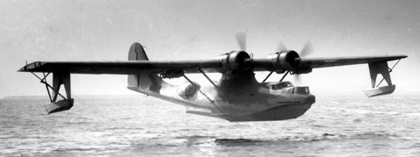
“Dumbo” Army Air Force Rescue PBY Catalina

Having taken aboard all the equipment including stores, fuel and a full crew, Thom thought it necessary to see how QS-20 would perform. He requested a timing run in the seaplane takeoff area which was about three miles long in Keehi Lagoon. With everything at the ready they began their run. With throttles wide open and one mile down course the boat labored to get up to near a plane and was lucky to get 20 plus knots. For some reason her stern hogged down making the bow ride high. Thom had the entire crew go as far forward to put more weight on the bow, but once again came up with the same results. Puzzled, Thom went over his list, noting the total weight distribution with regards to the 2/3rds fuel aboard; everything seemed to be within the ideal parameters.
Thom got with ex line-chief “Shooter” to discuss Shooter's ideas about attaching wedges under the transom or mounting tabs on the stern similar to the tabs used on the airplanes to “trim” the flight angle. Shooter was an old hand at setting up speed boats, dating from his days as a rum-runner along the West Coast. That was when he got interested in engine mechanics as he souped up the old WWI Liberty V-12 aircraft engines to evade the Revenuers; the Liberty engines were not too different from the Allison engines of the present time. Together they sketched a design that they thought might work. Where the newer planes used a hydraulic system, Shooter wondered if something on the order of a car screw jack on each side wouldn’t work as well.
That afternoon and throughout the night Shooter reworked and reduced the area of a set of old bomb bay hatch doors equipped with heavy hinges. He procured heavy aluminum flat bar to attach thwart-ship to each side of the keel at the stern. He then mounted the hinges and the modified doors to the flat bar. When all was ready for installation in the morning he lit up a cigarette, smiled contentedly, then settled down on a pile of rags to await sun-up.
The crew had to unship the rubber boat and tube frame from the stern. They then gathered up ten empty 55 gallon drums and placed them on the bow and began filling them with seawater, thus raising the transom clear of the water. The deck crew dived over the side and assisted with securing the makeshift trim tabs to the hull. The car screw jacks were temporarily installed; the water was siphoned out of the drums and they were put ashore. The rubber boat and its frame stayed at the dock while the boat made another trial run.
As before, the engines were revved up to 2/3 power. She again labored to get up to plane. Using the screw jacks, Thom had Shooter screw the tabs down. The bow lowered and the engines eased as the boat gained hull speed. Thom ordered more pressure on the tabs, then circled around for another go at maximum speed; the boat sped ahead faster than ever before.
That afternoon a template was made of the tab angles, factoring in the weight of the rubber boat and frame, and Shooter scrounged up several turnbuckles to replace the heavy truck screw jacks. After the rubber boat with its tubular frame was re-installed the crew let out a collective sigh of relief at all that had been accomplished for the day.
Just as they were about to relax after being dismissed from work for the day a siren sounded. There seemed to be a lot of activity taking place at the dock. Seaplane engines were firing up and a small harbor rescue craft at the dock was trying to get his engines fired up but wasn’t having much success.
Thom wasn't sure just what was going on, but whatever it was, it looked damned critical. Without hesitation, he hit the alarm bell and called down the chief to fire up the engines. The radio operator began monitoring the emergency frequencies.

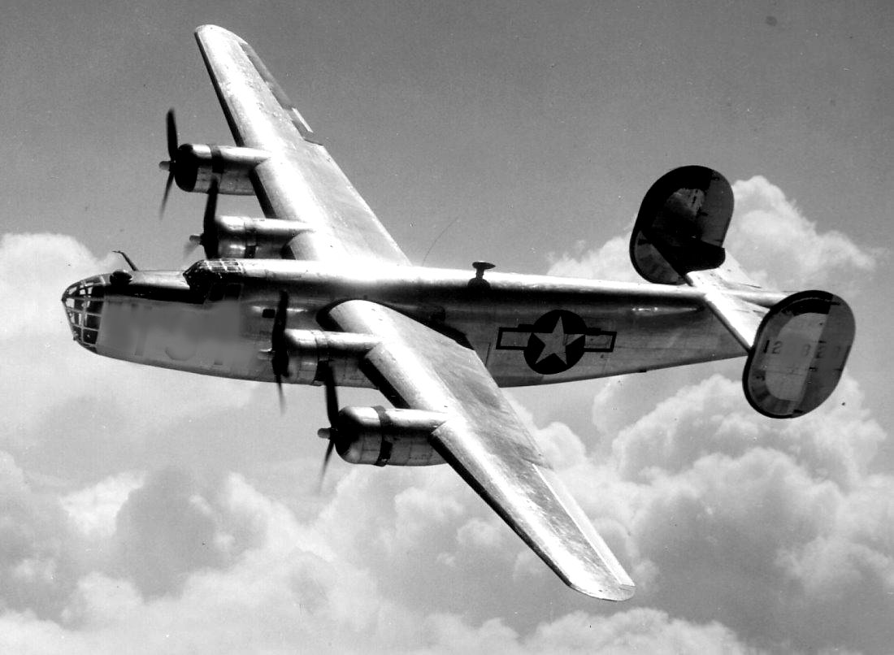
A bulletin said that a B-24 “Box Car” had gone down between Oahu and Molokai and that all services rescue elements were ordered to participate. The coordinates of the downed aircraft were broadcast over the AAF radio frequency. Thom plotted a course, considering the wind and current, and QS-20 sped towards that destination with an ETA of less than an hour...providing he traveled at his highest rate of speed. That ETA only lasted until they cleared Oahu’s wind shadow at Makapuu Point. The seas began boiling and the chop intensified; slowing the boat to less than 16 knots. Eventually Thom had to slow to less than twelve knots, fearing the seas would pound the boat to kindling.
Thom picked up radio communication between two PBY’s who were making circular passes searching for any signs of survivors or debris. Thom knew the amphibians wouldn’t be able to land on the sea in the bad chop and even if they did they wouldn’t be able to get into the air again; and that would mean two planes would be down and need to be rescued.
The Navy’s PT’s were alerted and underway, as well as their other surface vessels. However, considering the distance they had to cover either from Pearl or Kaneohe it could take them much more than an hour to reach the area.
If the downed airmen were not found soon, with evening coming on and with the present current and wind, Thom was fearful that those poor guys could be drifting towards the southwest and on into the open ocean.
Thom’s intuition was to go downwind well beyond what their present position coordinates suggested, thus allowing him to travel at a faster pace and then recalculate current, wind and drift and work his way upwind. The boat's angle with the seas on her port quarter made for a nasty ride down and almost the whole crew became seasick. The sun was nearing the horizon with evening not far behind. Judging by the flare patterns dropped by the PBY’s several miles upwind, Thom turned the boat directly into the wind and choppy seas. Slowly he zigzagged 30° in each direction to weather, digging his bow in at every swell; all hands were topside puking over the side yet keeping an eye peeled for people in the water.
Bud Hendricks, of the Emergency Rescue Squadron, spotted something ahead in the water and barked out ,“People in the water ahead!” Pointing off to port he bellowed, “Over there!”
Thom ordered his radioman to get on the horn and announce to all the searchers in the area that seven men, possibly more, had been spotted and that they should now concentrate their search in the location given.
Thom slowed the boat. The crew had the scramble nets (made of parachute riser straps) over the side and began tossing life rings toward the bobbing heads. Two QS-20 crewmen with Mae West’s and dragging a heaving line dove over the side to help bring the weary men to the side of the boat and net. The chop was playing havoc with the men as the boat, now dead in the water, was rolling on her beam ends from one side to the other; sometimes reaching nearly a 45° roll. Each time the boat would roll down, the crew would help the exhausted men grab at the highest rung of the scramble nets and as the boat rolled the other way those at the rail would pull the tired survivors aboard.
A Stokes litter, with a life jacket attached at each end, was lowered to assist a man who appeared to be having great difficulty in the small life raft. With assistance from the crewmen in the water they were able to float the injured man into the basket-type stretcher and pull him aboard.
The bomber pilot said that there were three men unaccounted for; the navigator, radioman and flight engineer. He thought they might have been trapped in their mid-section compartment and unable to free themselves before the plane went down. He said he heard the radioman calling for help on the emergency frequency right up to the time the copilot and he cleared their escape hatch.
As other vessels appeared in the area, Thom had his radioman announce the pilot's report and that the QS-20 was leaving the scene with a critically injured man along with six survivors and returning to Hickam Field.
Meeting the boat at their dock in Keehi Lagoon was the base commandant of Hickam Field, who praised the quick response of the boat and said that a letter of commendation would be entered into each crewman’s personal jacket.
The crew was elated with their success. Thom's shoulders were so sore from
the continuous back-slapping that he finally had to tell the men to ease off...though he secretly was so pleased with the performance of the QS-20 that he couldn't stop grinning from ear to ear.
The next morning Lieutenant “Bud” Hendricks left the boat, expressing his full confidence in their suitability for assignment.
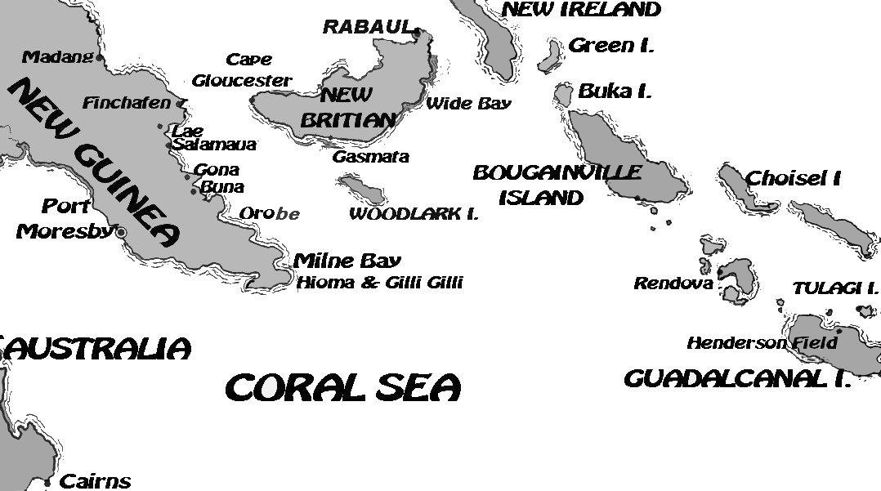
Within three days the boat was refueled and stores were loaded, filling every space, nook and cranny in the after crew quarters. Where there was once eight bunks now only six were available, forcing two men to seek other arrangements. In a way those two became the envy of the rest of the crew as Army cots were placed under the after-deck shelter and with the flaps down became private bunks, protected from the weather.
For the next 12 days they were towed to their next destination, Guadalcanal, by an Army Air Force H.O. aircraft recovery vessel which was smaller, but very much like the FS that towed them from the states, except that the H.O. had a flush mid-ship deck.
The QS-20 arrived at Iron Bottom Bay, just offshore from Guadalcanal, about eight days after a short stop at Funa-Futi, somewhere in the Ellice Islands. Henderson Field had become a replacement depot for air crews waiting for assignments to advanced air groups in other forward areas.
The H.O. towing vessel spent three days refueling and taking on stores. Word of the QS-20's rescue in Hawaii had preceded them and the crew was welcomed and invited to tour the different bomber and fighter commands.

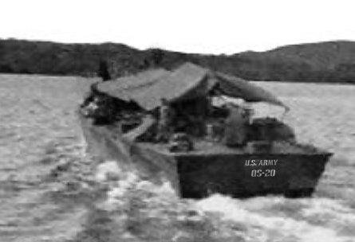
(Q.S. 20) Becomes BIRD-DOG
New bomber groups, both the Medium (B-25 “Mitchell’s”) and smaller (A-20 “Havoc’s”) were being formed and put through intense long distance bomber training. They flew across Bougainville in a series of continuous nuisance bombings at Rabaul, the major Japanese base in this area of the South Pacific, and also hit several targets in the Admiralty Group off the West coast of New Britain.
While being indoctrinated into their new ditching procedures, the squadron leaders inquired as to QS-20’s role in the newly established “Emergency Rescue Boat Squadron”, what the boat’s scope of responsibilities was to be, and what its “call sign” was. Thom didn’t understand their question and asked what they meant.
“You know…your…handle,” stated a pilot. “How should we make contact? How will we recognize your radio response?”
“Nobody mentioned that we needed a name,” Thom replied, “we’ve always answered to QS-20. What do you suggest?”
“It has to be a name that we can easily identify with,” said a pilot.
“You guys come up with something you’re comfortable with and we’ll be glad to use it.”
Someone in the rear suggested “Retriever,” another voice spoke up saying that Retriever was “Dumbo’s” call sign. (Dumbo was a group of Army Catalina PBY’s modified as a combination flying hospital and rescue amphibian, capable of long flights and strengthened to land in rough seas). The group tossed out several other names and “Bird-Dog” caught the fancy of the group and seemed to be acceptable by all.
With their new moniker being accepted, Thom went on hitting the highlights of the new organization and what the newly named Bird-Dog's duties were to be, but assuring them that nothing had been changed when they call for help.
“All services will respond,” he said, “the only difference is that ERBS (emergency rescue boat squadron) will be given advanced probable routes of the bomber sorties and will be assigned areas to picket not far from the targets and the bombers return routes; thus being closer to render aid if the planes need to ditch. Bird-Dog most likely will be based at advanced land and air operation locales.
Tech Sergeant “Shooter,” never met a stranger, even here on the ‘Canal’, and his nose never failed him in sniffing out liquor even though he had been dry for over a month. After they landed on Guadalcanal a group from his old P-40 squadron recognized him and that was almost the beginning of the end for poor old Shooter.
The next morning a jeep pulled up to the dock and a sergeant got out and boarded the boat requesting the skipper of the boat to come to the jeep. Curious, Thom came topside and made his way down to the jeep. An officer was sitting in the driver's seat. He motioned Thom to get in and then drove off a ways from the dock where he stopped and introduced himself.
“My name is George Pascoe, Lieutenant Colonel and wing commander of the Pursuit groups on the island. I've come to you personally to discuss a member of your crew; a Sergeant Cheuter. I was the one who ordered him to your boat instead of kicking him out of the service. I know he possesses talents that few men ever attain in a lifetime and for that reason, and the fact that I can't help liking the son-of-a-bitch, that I didn’t want to bust him. And believe me, I had the grounds to do so. Last night our flight line security had the ungrateful drunken bastard in their grasp but he eluded them while they were waiting for transportation to take him to the stockade.”
Thom looked down and shook his head. “I haven't seen him. He hasn't reported aboard since yesterday...I was beginning to wonder...”.
The irate officer warned, “I’ll tell you this; you better hope we don’t catch him, because if we do I’ll throw the book at him. He's had his last chance!”
Thom returned to the boat to find that a truck had brought supplies and a tank trailer with potable water and no less than 20 bundles of mosquito bars and was in the process of off-loading to the boat.
Sergeant 1st class Smilin’ Jack Sharpe called Thom aside and surreptitiously led him down into the engine room bilges where he pointed to a very dirty and drunk Shooter, dead to the world. Thom cursed, then bent down and checked to see if he had a heart beat.
He felt like kicking him but, instead, shook him until his eyes fluttered opened. “Wake up sleeping beauty, it’s time to go to work. Get those filthy clothes off and go topside and take a shower while we still have freshwater to spare. You smell like a damned Beacon Street bar-room floor!”
Shooter, now down to his skivvies, groped his way up to the deck; the electrician, one of his engine room cohorts, worked the handy-billy pump handle until a spout of water gushed from the garden hose, The electrician then put his thumb over the end of the hose creating a spray, which he aimed at Shooter. To most of the crew’s surprise, Shooter’s body was adorned with tattoos from neck to his ankles; every shape, design and motif imaginable. He was like a walking art gallery. After approximately 15 minutes of cursing, sputtering, shivering and moaning, a clean, refreshed and almost sober gentleman from Lamar, Texas was once again in control of his dignity and domain. He bowed majestically to the electrician, then to the crew that had gathered to watch, stuck his nose in the air and made his way below.
Thom received orders to take the boat along side the AAF’s H.O. boat waiting at anchor and prepare for a tow of seven plus days over roughly 1,200 nautical miles WNW of the ‘Canal’ to Hollandia. The voyage was without any major incidents other than the expected rain squalls, which at times were ferocious but only lasting about an hour or two at the most.
On arriving in the early afternoon at the large harbor of Hollandia, an Army medical officer came aboard and directed the crew to assemble for physical examinations. He instructed the men on the importance of taking their salt tablets and Atabrine pills, assuring them that the pills were the only protection against Malaria. He indicated the proof was in the jaundiced color of the old-timers who had survived several months without succumbing to the disease. The medical officer then charged the medics aboard (the cooks) to make sure that every man took the pills before each meal.
A courier came aboard with orders to stand by for a “hush-hush sortie” (their words) with another vessel for an after-dark cruise along the coast. After replenishing their needed supplies, several fifty-five gallon drums of diesel oil and many jerry cans (painted with white lettering “Fresh Water” on their sides) were loaded at the stern. The fresh water was a necessity. Drinking from ponds, lakes, rivers and small streams was strictly forbidden due to contamination and the ensuing dysentery and sickness that followed after drinking the local waters. The fresh water was transferred from the jerry cans to Lister bags (a larger canvas bag with spigots) and dosed with chlorine...thus making it safe to drink.
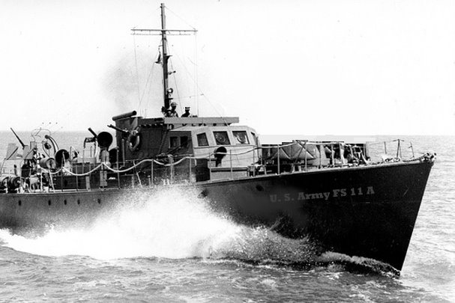
A group of infantry men with rifles and full field packs came aboard and searched for seating spaces about the already crowded topsides, which was strewn with 3’X 3’ cartons of “C” rations wrapped in a cheese cloth and wax-like coating. The crew did their best to lash everything securely with the modified scrambling (cargo) nets so the cargo wouldn’t wash over the side while underway.

A larger sleek looking vessel with US Army FS2A painted in small letters on the bow, appeared in mid channel and starting blinking towards Bird-Dog ordering them to follow, then both boats slowly headed for the harbor entrance.
They were underway for less than three hours when the lead boat slowed until it was barely making headway.
Thom pulled along side and the other skipper shouted instructions over a hailer, “On your chart number one you will notice the coastline with outcropping rocks and shoals. Cruise slowly southeast along the coast until you see a small light flashing two sets of “Item” (dit-dit…dit-dit) with ten second intervals. You will respond with an “Item” (dit-dit) once. Another light will come on about fifty yards off shore; it will be your range light. Keep them aligned and you will be guided into safe waters. On reaching the boat with the first light, they will instruct you the rest of the way. You will be on your own as we have another delivery further down the coast. See you back in port.”
Thom hailed back over the roar of the engines, “Good hunting!”, then ordered the gun crew to stand ready and load all weapons.
Shooter slowed both engines almost to the point of stalling as the boat kept its headway and at the same time inched its way inshore. A deckhand was already taking soundings with the leadline and finding no bottom.
All eyes were watching the coastline when in unison several men saw the two sets of double-blinks. Thom responded with a double-blink from a Aldis lamp that had its lens covered with a hood and black electricians tape, with only a narrow slit for the light to penetrate through. He then turned the boat towards land. Another light appeared to the right of the first light and Thom corrected his course until both lights were aligned. All the while soundings were taken as they entered the shallow waters.
A small rubberized boat similar to their own shore boat appeared out of the darkness and came along side. A man dressed in fatigues, without any chevrons or bars, came aboard and went directly to the bridge and ordered the stern anchor be made ready to launch. He then ordered that all Army passengers going ashore undress and put their gear in the inflatable boats. He had Thom ease to port as they passed an outcropping of rocks, then ordered the stern anchor tossed over the stern. All this was done while the boat was moving just enough to maintain headway. As they drifted towards the shore he ordered the engines shut down. They could barely see the out line of several people who were clustered at the waters edge, maybe 50 or 60 feet ahead of them. “Hold your stern anchor,” he called out to stop the forward movement of the boat.
Then he turned to Thom and introduced himself, “I’m Sergeant Hammer of Charlie company. Good of you to bring the supplies.” He held out his hand to shake instead of saluting. “We’ll be sending six people out with you, two are sick, two are injured and two are wounded.”
He then turned to the men undressing, “ Four or five of you will lay the drums on their side and roll them to the edge of the boat, wrap them in the scramble net and ease them over the side. They will float, they just need to be pushed ashore. The rest of you will toss the cartons over the stern and start swimming them towards shore. Men on the shore will take them to the beach while you return to the boat to off-load the jerry cans with the drinking water into the inflatable boats.”
The sergeant then asked Thom if he had two Stokes litters aboard to bring out the wounded. Thom went to unhinge them from the side of the pilot house.
Sergeant Hammer turned back to Thom and apologized for taking over his boat, explaining that this was his fourth replenishment operation and that he felt it would’ve taken too much time to pass the information to Thom and then have him relay it to the troops. “Besides,” he cracked, “they are my people now and I want them to know who's boss.”
After off-loading the supplies and taking on the men to return to Holandia, they cruised along at a comfortable 22 knots so they could make entry at first light. The sick, injured and wounded were made comfortable as Bird-Dog’s cooks practiced their medicinal expertise.
On entering Hollandia, Bird-Dog signaled the station high on the hill at the harbor’s entrance that they had wounded aboard and were promptly directed to go to the Navy dock at the far end inside the harbor. Ambulances would be waiting. After unloading the wounded they returned to their slip in the finger bay behind the hill at the entrance of the harbor. Bird-Dog tied up to a grounded LCM that appeared to have seen its last day and was just across the dirt roadway from a cluster of tents that housed a Harbor Craft unit. They took their meals with the group.
A day passed and everyone started asking questions and became concerned that the FSA boat hadn’t returned. Thom found out at the operations tent that the other boat touched on some rocks and had to be pulled off by a Navy boat. It was being towed to Manus, as they had the only dry-dock available in the area; thus putting more responsibility on Bird-Dog to take up the slack.
Thom pulled Shooter aside to ask him if there was anything that could be done to reduce the loud roar of the engines. Shooter responded that he was thinking the same thing but unfortunately it might require a major change in the layout of the boat.
What Shooter had in mind was an old ruse the rum-runners used to escape the “feds” during prohibition in the late nineteen twenty’s and early thirty’s. In their need for silencing the 12 cylinder Liberty aircraft engines (developed, but few put in use, during the later stages of World War I) the rum-runner crews adapted 55 gallon fuel oil drums as mufflers to silence the noisy engines.
QS-20 was the first boat of this experimental class and was greatly modified from the original design, so maybe one more change wouldn't be stretching the rules too much. Shooter asked Thom for time to think it over.
American PT’s and the British MTB’s usually had water cooled exhausts blowing out the transom, with up with to four or six exhaust pipes made up of six inch heavy corded and rubberized hoses traversing through the after compartments and berthing quarters. Not only did they use up needed space but were in the way of maintaining the steerage area.
A few of the smaller boats exhausted out their sides; this was learned during the short life of the high speed rum-runners. However, the drawback of this idea was the need for risers to elevate the cross-over manifolds so that seawater would not flow back into the engine in rough seas.
With the early introduction of engine power to propel a vessel, exhaust was directed through a vertical stack; at first it was to create a draft for steam vessels to increase the flow of heat up through the water tubes. This arrangement stayed throughout the years. Shooter sketched many alternate designs, but he kept returning to the stack configuration. The usual exhaust manifold was designed to accept the extremely hot spent gasses while somewhat quieting the engines roar. Water jacketing was in common use in boats, but to build or add mufflers of a size to reduce the noise output and still keep the exhaust cool required much more equipment than was offered in this forward war area.
But this did not deter Sergeant Shooter; he visited an armored tank company and “borrowed” a large used muffler to examine. He opened it up and dissected every phase of the muffler, taking measurements and configurations, then putting them down on paper as an engineer would to make a blue print. When finished, he offered his plans to Thom.
Thom studied the plans. “This looks impressive but how can we possibly make it...and if we did make it are you sure it would work?”
“Give me some time to scout around at the bomber airstrip up by the lake and I’ll answer that question when I get back,” Shooter responded.
Thom was called in to the transport operations office and given orders to take over the run that the FSA was unable to complete because of her ‘touching the bottom'. This other isolated perimeter group was only a few miles south of Aitape and was under frequent attacks from the enemy being driven up from the Wewak area by the 41st Infantry Division; and they needed supplies and help immediately.
Thom was given aerial photos along with larger hand-drawn detailed sketches of the area and a list of radio frequencies with their call signs. He was instructed that if contact couldn’t be made by radio they were to use the same procedure with the range lights as used in their first run.
The skipper of the ill-fated FSA boat, an Army 1st Lieutenant from the Army’s Harbor Craft unit of the Transportation Corps’ “Ship and Gun Crew” (modeled after the Navy’s Armed Guard) came aboard and informed Thom that while aboard he would only be acting as a pilot with local knowledge and that Thom was in total command. The Army’s 1st Looie added that his boat was a medical evacuation boat ‘sort of a sea going ambulance’ and had been operating down coast at Buna and Goodenough Bay, taking the more seriously injured to an Australian Hospital at Ahioma near Gili Gili in Milne Bay. That part of Papua had few usable air strips or roads and the few amphibian Dumbo’s were the only other form of emergency evacuations that could be counted on.
Bird-Dog was a swarm of activity; again loading those water proofed boxes of supplies, jerry water jugs, and this time mortar rounds and assorted ammo. In addition, a full deck-load of replacement troops; about 24 in all.
Though it was dark Thom could make the outline of the mountain peaks, thus allowing him to take running bearing fixes. After a while he decided it was time to head for a closer look at the shoreline to see if he could pick up the double blink of the signal lights.
Everyone was at their action stations; even the troops were on their bellies with their rifles at the ready. Thom slowed the boat down as they closed in towards the shore, searching for that speck of light.
The 1st Looie pointed to a faint outline of a rise, maybe a small hill and said, “This is where we should start to enter; we should have seen a light by now.”
Thom called down to the radio operator , “Are you picking up anything?”
“No sir.”
“OK try calling them...try on all frequencies.”
There was an odd phenomenon aboard the boat, everyone was whispering and they were yet a half mile or so off the beach and the damn engines drowned out any noise short of gunfire. What was the need for secrecy?
Thom was getting antsy, “Ya think maybe we should show a light?”
The 1st Looie shook his head, “I wouldn’t recommend it yet.”
The two men stood silently, each contemplating the next move, when they heard a shout from the radioman, “Their perimeter is under attack and warn against coming in! They're being attacked from the west...about one mile from their headquarter location. They asked if we have anything to fire at the enemy. They could sure use our help...what'll I tell 'em?”
Using the binoculars Thom saw flashes some distance down the coast and handed the glasses to the Army Officer for his opinion. Meanwhile, Thom looked at the chart of the area and concluded there was plenty of water for them to cruise back and forth just off shore within range of both the 50’s and 20mm’s.
“Tell 'em we'll do what we can,” Thom shouted at the radioman, “ And ask 'em if they can fire a flare or a large ordinance into the enemy position!”
A few moments later a large flash lit up a small rise. Thom gave the order to fire the 20mm’s and 50’s continuously as they sped down, then reversed course firing from the opposite side of the boat.
The short bursts of fire were aimed at the hillside, many small explosions could be seen as the tracer rounds, ranged on the target, and their slow arcing trajectories with the intermediate loads of high-explosive, armor-piercing and tracer rounds seemed to slowly hang in the air forever on their way in.
After two or three runs the radioman yelled out, “Cease fire! The headquarter command radioed that his troops are re-taking the hill. He also added that you are welcome to deliver your cargo in their now 'safe and humble harbor'.”
An inflatable boat met them just offshore and guided them into a small indentation of the coastline with a pier the looked like it was built on stilts.
The troops were ordered to take their gear ashore and return to take off the fresh water jerry cans and anything else they could carry, the heavy stuff would be transported ashore by raft or rubber boat. He didn’t think the rickety pier would hold much weight.
An officer came out on one of the inflatables and inquired if there was a medic aboard; he said that they had several wounded that needed surgical attention. Both of the cooks picked up their tote bags and left on the inflatable with the officer.
The officer took the cooks to an evacuation tent where two men were working feverishly over a man bleeding profusely from a chest wound. The medics from Bird-Dog took over and eventually stabilized the man, then started on another.
“Where’s your Doctor?”
“He went to the scene of action to treat a group of casualties and we haven’t heard from him since. We just hope he wasn’t involved in that fire fight,” one of the young base medics said.
Several stretchers of men were brought in with varying degrees of wounds and none had been treated by a learned medic, indicating that the doctor himself might be a casualty.
Thom, who had made it ashore by this time, came by the tent and asked for an update on the condition of the men. He was told they should be evacuated immediately, Doctor or no Doctor.
Thom went to the command tent and suggested that Bird-Dog leave at once, taking the wounded with him. A Light Colonel walked in and as the officer at the desk was giving his report, Thom Recognized him as the man that took such an interest in the QS-20 in Honolulu. Tom saluted, “Hello, Colonel Robb. In case you didn’t already know…that boat you see at the pier out there is because of you. You are the proud father of 'Bird-Dog'.”
“My god it’s great to see you. About an hour ago I had thoughts of a conversation I had in Honolulu with a young man and his dream of MTB’s along the North African coast. Not a lot of dreams come true but yours did...and in a big way. Saving our butts!” Colonel Robb slapped Thom on the shoulder and shook his hand.
“Nobody’s heard from your Doctor,” Thom said, almost blushing, “but thanks to you listening to a green kid, they’re getting treated by our medics from the boat. If I may suggest, we should be getting the wounded back to Hollandia as fast as we can.”
“Go on load up and take off,” the Colonel said, then turned to a Captain at a desk and asked, “How many will be evacuated?”
“Twenty-six men sir, twelve are in serious condition.”
“Go on ‘git’, Mister Lifesaver!” The Colonel smiled and held out his hand again.
The wounded were loaded and Bird-Dog headed back to Hollandia. As they approached the ASW (anti-sub-warfare) nets, they blinked for permission to enter, making note that they were carrying wounded in need of immediate aide.
The blinker light responded advising them that the USS Comfort had just arrived and was at the Navy dock at the far end of the bay. Thom thanked them and roared towards the big Hospital ship and began blinking the Comfort to stand by to receive wounded. As Bird-Dog approached, the Comfort responded by blinker that they were ready to receive.
(A side note of interest and fact. Some Months later the Army Hospital Ship Comfort, dressed in her white paint and red crosses, was bombed and strafed by Japanese aircraft, killing several members of the medical staff, including six nurses.)

On returning from their frequent runs down the coast the crew of Bird-Dog would fall into a “hurry up and wait mode”. After a day or two the crew would get antsy, the burning sun and high humidity took the sap out of them, not even a wisp of breeze could be felt while tied up in the small cove behind the hill.
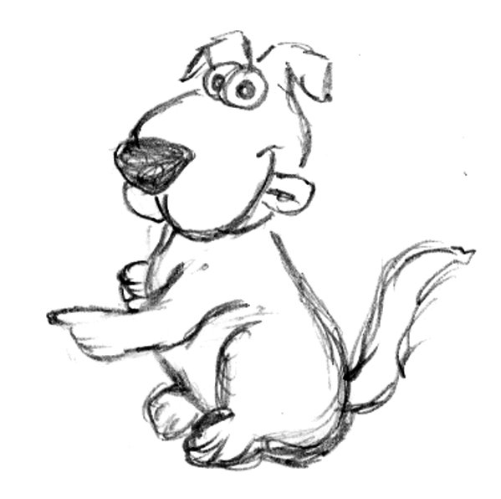
During the boat's down time one of the radiomen, who fancied himself a sketch artist, did some painting on each outboard side of the bridge wing. Now this boy was from Lower Manhattan and had never ventured outside New York until drafted. A city boy through and through. In small letters he painted “US Army QS-20”. Under that he painted his version of a bird-dog pointing at his prey. Under that caricature he added a couple of symbols that looked like explosions, representing engagements with the enemy and below that were two rows of what looked like parachutes, indicating air crews that were rescued and another row with many red crosses indicating wounded evacuees.
When he was finished he told the crew to come and look. They dropped what they were doing to view his creation. They stood in awe for a few moments then burst out laughing, holding their arms out like pointing to something in the distance and commenting just short of ridicule that what they were looking at wasn’t a bird-dog's traditional pose. However, after a few moments had passed, one of the crewmen announced that he liked it, saying it was an original. Even Thom recommend that they adopt the symbol...deciding that the artist had captured the heart of the crew with his dog.
Several days later another flare-up had erupted down the coast putting all boats on stand-by. Several trucks with men and supplies arrived at the dock. Everyone was put to work loading everything aboard the boats. A cherry picker transferred several 55 gallon drums of diesel fuel for the perimeter’s generator and of course the many fresh water jerry jugs.
While planning the trip the skipper of the FS2A boat suggested that he take the first entry near Aitape because the other entry required a more maneuverable vessel. Since BIRD-DOG had previously made entry at the other cove without any problems he hoped that Thom wouldn’t mind.
That evening at the last light of day the two boats took off. As Bird-Dog had greater speed at twenty plus knots and had further to go, Thom opened up the throttles. The FS2A, a 112 foot wooden Australian-built boat with two six cylinder Stirling aircraft engines, was capable of only doing 18 knots max...without the added cargo load weight.
Their approach to the perimeter area was uneventful and the unloading of supplies went like clockwork. That flare up of a week ago was probably Japan's last bravado. Many Japanese were surrendering because of lack of food...especially after a few of their dead buddies were found with their innards cut out. The thought of cannibalism by the native Papuans scared the hell out of them. The GI command reported they had so many prisoners that they were calling for an LCI (landing craft infantry) to come and get them.
They arrived back in Hollandia and docked the boat amongst a clutter of LCM’s that were used as lighters (ferries) to shuttle cargo ashore from cargo ships awaiting their turn at the few operational docks in the harbor. They were met by the Harbor Master delivering a large manila folder with orders from the Army Air Force to make ready for sea and evacuation of their area by fifteen hundred hours the next day, at which such time instructions and charts would be delivered.
A couple of weeks prior to their Aitape cruises the crew had noticed all of the LST’s and other landing crafts had disappeared from the port side inner harbor off the main channel. Word came down of landings at Biak and Cape Sansapor. They heard that there were large airstrips in both places and according to the scuttlebutt the crew deduced that was probably where their boat was going.
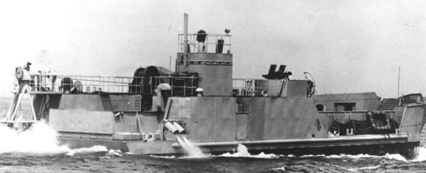
An LCT (landing craft tank) loaded with bulldozers and trucks was their assigned towing vessel and crept along at seven knots. With no breeze and being only one degree below the Equator, the heat seemed unbearable. The crew of Bird-Dog felt sorry for the crew on the blistering steel deck of the LCT. Even with canvas covering most of the exposed deck to give some shade, the heat must have been intolerable.

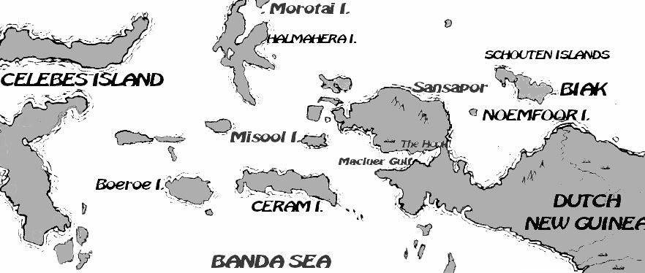
During a two day layover at Noemfoor a bomber pilot from a B-25 Medium Bombardment Group came aboard and was assigned to act as the Navigator-Pilot for Bird-Dog's independent run to Cape Sansapor, and explain call signs and procedures for any in-flight emergencies. He indicated also that there might be an unassigned pilot or navigator (temporary not assigned to flying status) as a passenger adviser for their scheduled bombing routes.
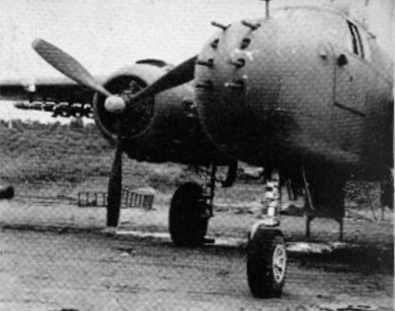

He explained that his Commanding Officer, then a Major, remembered the Bird-Dog from when he went to Hickam Field several months previously for instructions on the new modified B-25’s, with their installation of 6-50 caliber machine guns instead of the bombardier’s Plexiglas nose-cone.

At Sansapor the boat tied a line to a canister-type float anchored several boat lengths off of a floating wharf or barge. They tied a stern line to the barge then secured an extra anchor mid-way on the canister line which, when sunk, pulled the boat about 15-20 feet away from the wharf (commonly called a Mediterranean anchor). If a person wanted to go ashore all he had to do was pull on the stern line until he could jump to the wharf, then let it go. They did this because this was the only sheltered area around but the water was too shallow to tie up to the makeshift wharf.
Thom and the Pilot, a 1st Lieutenant, went ashore to operations and Thom was introduced all around to about five pilots and their crews that were in the midst of a briefing. A Major, who seemed to be the boss, invited Thom to stay for the briefing explaining that it was possibly the first of many briefings he'd attend. The Major asked Thom if he remembered him form Honolulu.
“I certainly do. You were the Officer who gave me my first order to take command. I’ll never forget it.”
There were two large sheets of plywood covered with charts that were set up on make-shift easels. On one of the charts was an outline of an island. There was a sheet of celluloid lying on top of the charts and on the see-through material were colored yarns and staggered arrows going in and then coming out, numbers and letters, wind direction, compass headings. Had Thom not have been familiar with marine navigation he would’ve been totally confused.
The Major asked Thom, “Does any of this make sense to you?”
“Yes sir it does, but I don’t see any names or targets.”
“Good observation Thom. The navigators carry that information in their heads. Your concern is to be in the area when they are returning from their objectives and start home...say 20 or 30 miles homeward bound from the target.” The Major continued, “You will be notified and apprised of location several hours before the strike, at which time you will depart and picket that area until you are relieved or, depending on the circumstances, head back after rescuing injured fliers in need of major medical assistance. Is that fully understood?”
“Yes sir.”
“When will your boat be ready?”
“The crew is removing all the nonessential equipment now and should be ready within an hour or so. I’ll have to get with my engineer to confirm it.”
At 0300 everyone was turned out. Thom was called to the operation tent and was given a rundown of his courses and a list of frequencies that had to be monitored. He was told to get underway as soon as he could. The dispatcher said he had about six hours to get to his rendezvous which was in the direction of Morotai Island, north in the Halmahara group.
The sea was smooth and the weather was clear. Shooter had convinced the flight electronics officer of Bird-Dog's need for radar; he was able to con the officer into letting them try an older model removed from a bomber undergoing major repairs. Unfortunately it only had an effective range of 8-12 miles and swung back and forth on an arc of 60 degrees. However, while observing the six-inch scope under the light-inhibiting hood, it did show the outline of the coast and small blips of any objects on the water. Thom, who only used the radar sporadically, was not planning to use it because word came down that the Japanese were now capable of picking up radar signals. Besides, the darn thing seemed to always scramble when the engines were running, suggesting that there was a frequency leak in the magneto system of the engines. That drove Shooter crazy trying to trace the problem.
While cruising in their picket area and monitoring the radio, a 1st Lieutenant observer, who was a last minute addition to the boat's crew, explained to Thom some of the bomber group's strategy and how they confused the enemy by taking doglegged routes.
The high speed A-20’s were to follow the B-25’s because the medium bombers had a Navigator/Bombardier and the A-20’s did not. After attacking their primary target the A-20's were ordered to go in low to catch the enemy planes on the ground and after carrying out all procedures were given permission to freelance and strafe any anti-aircraft batteries and fuel dumps.
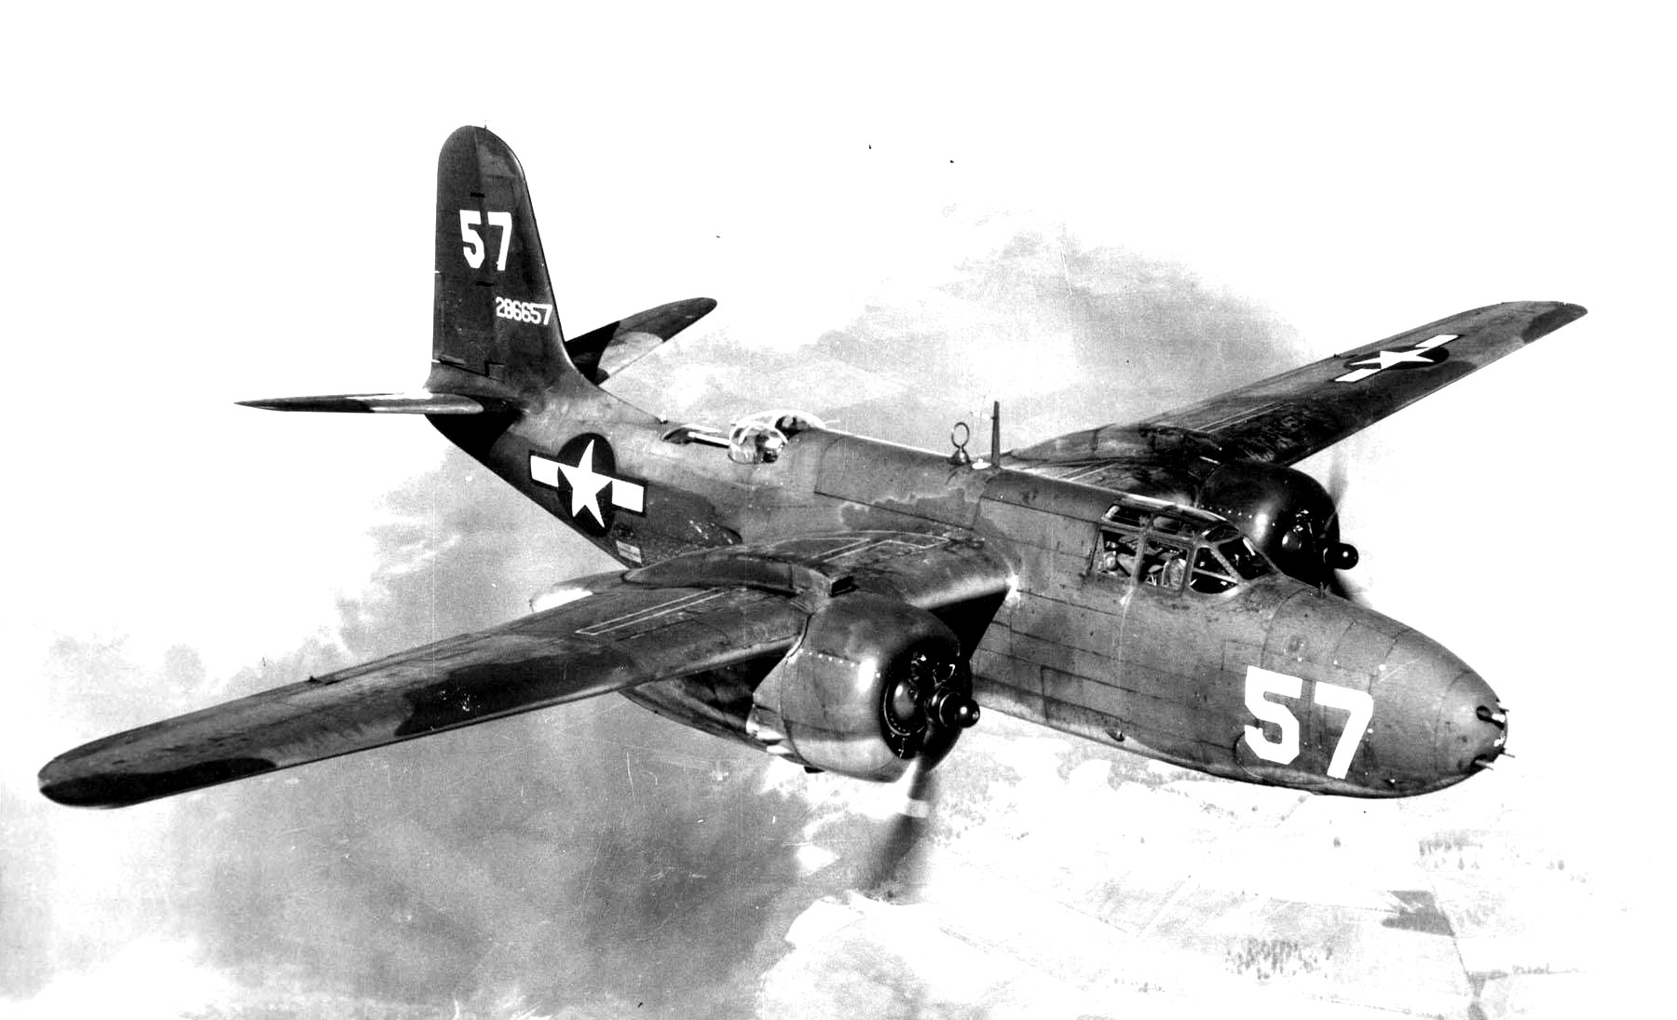
A-20 HAVOC

The B-25’s would go in first, loaded with several thousand pounds of bombs and flying at a higher altitude. They would drop their loads on prearranged targets, giving time for the A-20’s to wreck their havoc. On the last several raids in the Halmahera’s the enemy put up a tremendous amount of Ack-Ack and sent up interceptors from fields on other islands. Apparently the Japanese had decided to make their final New Guinea stand from this area and escape south through the Ceram Sea Islands.
All this was interesting to Thom, but he was chafing at the bit and wanted to get the boat closer to the scene of action. The Lieutenant had a hell of a time restraining him, but finally got through to him that Bird-Dog must remain in this area because it was where any damaged airplanes would head for.
After an hour on the scene the radio finally broke silence. At first the banter was like listening to a crowd at a football game...then things got serious and the cussing took over. There was a Mayday call followed by what sounded like some one in authority ordering everyone to stop talking. The Mayday came through once again giving his call sign, “This is Betty Boop…we are in trouble…no elevator control…Rico come in…Rico are you OK?”
The Lieutenant recognized the call sign “Betty Boop” and said Rico was a Staff Sergeant Flight-Engineer/Gunner aboard the evidently disabled B-25.
The radio blasted again, “This is flight leader I am below and behind you, I can see your tail feathers ruffling… can you change course...can you steer left or right?”
Betty-Boop responded, “The after-guard finally answered…Rico crawled back and said everything was torn apart…there’s no response to my controls…I can only steer by adjusting my throttles…I can’t climb…I don’t think I can land this bird at home…I’m gradually losing altitude…Betty Boop over.”
“Try for Bird-Dog. We will escort…good luck.”
“Bird-Dog…Bird-Dog…do you read me...this is Betty Boop...Our ETA 15…do you read me...over?”
“This is Bird-Dog…you are five by five…seas smooth…wind from northwest ten knots…suggest landing same heading…standing by…good luck…any injuries?...over.”
“No injuries…see you soon…out.”
The crew aboard Bird-Dog made sure everything was in order to receive visitors. The inflatable was launched and towed at the stern. Scramble nets were hung over the side, remembering the rescue scene off Molokai when the B-24 went down.
They spotted the flight leader first, about thousand feet higher than the troubled B-25 who was coming in low, only a few hundred feet over the ocean and about one mile away. She made a wide circle around Bird Dog and then headed into the breeze, hit the water then bounced up and settled, nose first, with her tail pointing to the sky and their inflatable along side. Within a minute or two she dove for the bottom.
Aboard Bird-Dog the crew saw several men who had made it out and in the water before the plane fully disappeared. Three got into the rubber boat and made way for Bird-Dog, leaving the other three hanging on to a small one man floatation device.
The first three to be rescued had less than severe injuries; a gash in the forehead, a wrenched shoulder and an obvious broken wrist. The other three were in good condition and had offered to stay behind because the inflatable boat was over-loaded with six people aboard.
Word was passed to the flight leader circling high above that all were safe.
The Lieutenant observer informed Thom that the other flight was temporary put on hold and that they should return to their base.
Back at base Bird-Dog was alerted for a different rescue picket area outside the normal umbrella protection and was ordered to prepare to stay in the assigned area for as much as a week in a group of islands in the Ceram Sea.
Thom, Sgt. Sharp, Shooter and Sparks, the boat’s radio operator, were called to the operations tent. They were introduced to the reconnaissance pilot who posted several photos on the display boards with a large scale chart of a group of islands off to the side. Colored strings were pinned from each photo to an island on the chart.
The Bombardment Group Commander, a Lt. Colonel, was conducting the session and had several of his flight leader pilots in attendance. The recon pilot pointed out high concentrations of enemy stock piles, air strips, troop encampments and defensive AA concentrations. Primary targets were designated with red circles, secondary blue, and the green was for targets of opportunity.
The communications officer assigned frequencies to be used and monitored, then pointed out to the flight leaders that Bird-Dog would answer any communication with curt replies to keep the Japanese from triangulating their radios to their position. He also announced that a Dumbo would be on stand-by.
The Colonel took over the briefing and announced, “This is a maximum effort; we will be on our own for this operation. We’ve been advised that the Japs appear to be abandoning New Guinea proper, no doubt to consolidate their forces elsewhere, but at this point we don't know what in hell they're doing. The navy is recalling all her resources, including the PT’s, for a major push elsewhere. They wouldn’t elaborate where.” He then added, “Bird-Dog will stay in their assigned area for the duration of this operation and will stay in her shelter near Macluer until called by a plane in need. She will monitor all assigned frequencies. If further assistance is needed Bird-Dog will call for a Dumbo.”
Then turning to the Bird-Dog crew the Colonel said, “You'd better take a tent, cots and extra supplies...and don’t forget the extra mosquito bars. We hope we can quickly neutralize the Japs in this area by continuous attacks, but it might take a while.” He looked at his watch and ended the meeting with, “The clock is now ticking.” He looked at Thom, “Tell your crew to remain for additional briefings.
The communications officer gave Thom copies of the charts and photos. Included were aerial photos of a secluded cove in Macluer Bay, some ninety miles distant (as the crow flies) from the scene of operations and almost two hundred miles from home base.
Some of the photos had penciled-in circles of what appeared to be barges or rafts just offshore of some of the coastal inlets. The Colonel pointed them out to Thom. “What you see may be Jap landing barges that are being used to evacuate their remaining forces under the cover of darkness. It will be your secondary objective to annihilate as many as you can. Oh…and one more thing, an infantry Colonel wants to meet with you….he should be arriving soon. It seems this new area of operations is attracting all branches. Be sure to clear with me before any changes are made.”
“Yes sir,” Thom replied.
Two squad tents were made available for Bird Dog’s crew and arrangements were made for them to eat in the ground crew's mess. As before, at least three crewmen had to stay aboard in the event of any emergency. Smilin’ Jack Sharp, Shooter and Thom had the watches divided between them.
During the meal an officer in fatigues entered the mess and stood, searching the faces of the men eating. He spotted Thom at a table in a corner of the mess, raised his hand in greeting and smiled. Thom looked up at the man approaching, instantly recognized him, saluting as he stood up. Colonel Lee Robb, now with eagles on his collar points, returned his salute.
“Good to see you Colonel,” Thom said, “I see that you got out of Aitape in one piece. Is that a bird I see? Congratulations.”
“Can I have a few minutes of your time…in private?’’
“Sure thing,” Thom said, then turned to Sergeant Sharp and told him to have his gunners strip and clean the weapons and said that a fuel tanker truck was scheduled to come to top off the boat's tanks, deliver several 55 gallon drums of fuel, and that a large delivery of rations was to be taken aboard and stowed.
Thom motioned for the Colonel to follow him to his tent. As the two were walking the Colonel gestured to two men, dressed in fatigues, to follow. On entering the tent Colonel Robb introduced the two men as Infantry Sergeants under his command.
Colonel Robb began their conversation with the need for secrecy. Then, pulling out a sheaf of papers from inside his shirt, he handed them to Thom to peruse. After Thom had examined the papers, Col. Robb said that information had been received from a Brit and Aussie RAN task group operating out of Darwin in the Banda Sea area south of Ceram Island, who were searching for a stranded party of Dutch East Indies nationals in the interior near the Kebar Plain in Dutch New Guinea. The information was that the Japanese were abandoning New Guinea and were presently transporting their military to the Island of Ceram.
“But what is so disturbing, Colonel Robb said, “is the reported slaughter of the slave supply-bearers that the Japs had taken from China, Korea and the Philippines, with promises of providing for their families while they were gone. Now, rather than waste their time and resources removing them along with their troops, the Japs wish to annihilate them. A Dutch Coast Watcher that we can only identify as 'DV', passed this information on to our Allied intelligence. There could be several hundred slaves involved.”
“We have to find out if there is any way we can make contact with this Dutchman…we don’t even know if he exists…it could all be a hoax or some sort of diversion from the Jap's real plan,” Colonel Robb continued. “We'd like to ask you to find a place aboard your boat for these two men while on your coastal recon trips. These men are well trained in jungle survival; they have a low frequency portable radio and can stay in contact with you when they are ashore. Their assignments could very well contribute to your overall safety.
“I'll have to clear it with the powers that be,” Thom said, “but I see no reason we can't make room for these two.” He grinned at the two men, “We'll put a rope on 'em and tow 'em behind, if we have to.”
Operations gave permission for the extra passengers and for Bird-Dog to leave when loaded, allowing her to arrive at daylight in a general assigned area in the Macluer Gulf to check out the most secure and defensible base.
About two hours into their journey it became obvious that they were more heavily loaded than anticipated and were unable to reach their planing speed of eighteen plus knots...which delayed their arrival until mid-day.
Early morning a pontoon aircraft was spotted circling their position. The IFF didn't recognize them to be friendly. Thom ordered the boat on full alert, then suggested that in order for the boat to move faster that they prepare to jettison the six barrels of fuel, explaining that the barrels would float and that Bird-Dog could retrieve them after the emergency passed. The crew couldn’t make out the emblem on the plane's fuselage; it did have a red center with what appeared to be a blue and white ring, but by the time they decided that the plane might be an Aussie or Dutch, therefore friendly, she disappeared.
No longer feeling under a threat from the long-gone float plane, they continued on a slow course to one of the bays shown in the aerial photos and scanned for any activities on the shore. The radioman, in addition to his other duties, was an excellent sketch artist and began laying out what slight elevations the lowlands had to offer. He set bearings, noting approximate distances from the coast towards the interior, as they cruised along the coast from one bay to another. Meanwhile, the crew took lead-line soundings which were then noted on the sketches.
One of the aerial photos showed a sheltered hook within the gulf. They approached the inlet dead slow, anticipating being attacked by any Japanese in the area. Everything seemed unbelievably serene. A consensus among the crew suggested that this was a perfect hideaway for their base of operations.
The depth of the water within the hook was sufficient to anchor the boat. The crew took a mooring line and secured one end to the bow anchor and captured a 55 gallon fuel drum with several barrel hitches and sent it over the side to act as the seaward buoy and the same assemblage with another drum for the after buoy. The stern anchor with another line was strung between the two buoys so that the crew could boat-hook the line and bring it aboard fore and aft, thus they could evacuate the bay in a hurry without having to weigh the anchor or maneuver to head out of the small inlet.
The inflatable boat was worth its weight in gold; enabling them to move, with ease, everything that had to be put ashore. The tent was erected and all supplies, radios, generator, and weapons were put under cover of the tent just as a downpour started. Thom came in lugging the box of DDT canisters. “This place looks perfect for mosquito breeding. Be sure and bomb the tent tonight before bedding down. And use the mosquito bars! I don't care what that Army Medical Officer in Hollandia said about taking Atabrine pills, there's nothing like a healthy dose of DDT to stop those little bastards in their tacks.”
Sergeant Smilin’ Jack (second in command) and Thom, along with the two reconnaissance sergeants under Col. Robb's command, hiked to a slight rise at the entrance to the inlet to search for a suitable observation post to watch for any intruders by air or sea. They found an excellent spot with a view of Bird-Dog and the entrance to the cove. All agreed that this location, with a fifty caliber MG, might be the best deterrent to any unwelcome visitors.
While the men were scouting the area the boat's horn started honking. They could see the crew frantically waving their arms, so immediately ran down to the inflatable boat and headed out for Bird-Dog.
Scrambling aboard, Thom was notified that a message had been received from Headquarters at Cape Sansapor that “DV” made another plea for a response to the seriousness of the problem concerning the slave labor held by the Japanese. Command authorized Thom to use any of his resources to comply with DV’s request, with the caveat that he was to use extreme caution and, if needed, return to his original mission duties.
Half of Bird-Dog's crew was put ashore to set up camp. Smilin' Jack was left in charge with orders to monitor the radio and relay any messages to the boat. As they prepared leave to reconnoiter along the coast Thom pulled Smilin' Jack aside, “You might want to establish a defensive position at the observation post we were just scouting. Good Luck.”
On board Bird-Dog were the two Infantry Sergeants and as the boat cruised along at 16 knots on the flat ocean they studied the aerial photos, attempting to catch the lay of the coast with its many inlets and river deltas in the event they had to traverse it on foot at some future time. The radioman was busy making elevation, navigation reference points and sounding sketches of the coastal inlets and significant landmarks along the way.
After passing several outcroppings or minor points of land and about 15 miles up coast from the hook, the radioman began picking up a faint Morse code tapping, “dah-dit-dit…dit-dit-dit-dah” in his earphones which began getting stronger by the minute but as they continued on their course the dot dashes became weaker. The radioman had called for the skipper when he heard the first faint Morse code signal, “D V”.
Thom ordered the radioman to call back on air and in plain language, “DV we received your call sign. Can you talk? Over.”
“You are three miles down wind,” returned a clear voice. “I'll use a mirror to lead you in.”
Thom swung the boat around and headed towards shore, slowing the engines to a crawl. He ordered the crew to launch the inflatable with the outboard motor and suggested that the two sergeants arm themselves and go ashore with two of Thom's men to size up the situation. “Since you’ve been trained for this sort of activity I'll leave it to your better judgment as to what procedures to take; but above all take no chances with my crew or jeopardize the boat! Good luck.”
The men descended into the shore boat with their backpacks and .30 caliber Carbines, customized to automatic mode by using two foot-long magazines coupled together and staggered so they could be end-for-end inserted as they exhausted their rounds.
The crew aboard Bird-Dog took their gun stations, setting up imaginary targets along the coast as they watched the inflatable close in on the beach. As the inflatable was about to land, three natives appeared from the dense vegetation behind the small beach area, their hands held high. A tall black man with a fuzzy-wuzzy hairdo wearing a rust colored lap-lap stepped forward and talked while the Sergeants covered the three men with their weapons. After a bit two natives waded out to assist in the landing; there was no sign of hostility or confusion. The tall black man got into the inflatable, leaving the two sergeants ashore and came out to Bird-Dog along with the boat operator.
The black man climbed aboard and with a perfect British accent introduced himself to Thom, “Good day Captain. My name is Theodore De Vries of the Dutch Coast Watcher Service. Your chaps ashore there,” he pointed to the two Sergeants, “have authenticated my identity. My friends call me 'Teddy' but I'm officially known as De Vries. Every time, for the past week, when one of our ally planes came near I tried to raise them on the radio, with both the key and voice but I never got a reply and had about given up.”
Thom explained to De Vries that the planes had indeed heard his weak messages and that was the reason for the boat searching in this area. He asked, “Just what information do you have that you are so willing to jeopardize your cover?”
“The Nips are slaughtering their slaves rather than take them with them as they abandon this part of New Guinea. I have three Chinese in my camp that were able to escape the killings and they’re begging me to help rescue the rest of their group of about fifty, as they have neither food nor weapons to defend themselves.”
Thom shook his head, “Damn, I was hoping that part of your story wasn't true.” Then, using the Aldis lamp, he blinked the Sergeants on shore, asking them to remain ashore to recon and gather what information they could, while he took the boat along the coast to search for any signs of activity.
All their attention was directed towards shore as they cruised in close. Then, over the muffled purr of the engines they were surprised to hear the whine of an aircraft as it pulled out its dive, as if strafing them and clearing them by only a few hundred feet or so. Luckily they spotted the white star markings before the gunners opened up. Thom grabbed the mike and yelled into it, “This is Bird-Dog we have important message to be relayed to ‘Bo-Com’. Please acknowledge.”
“Go with your info, after I relay your orders.” There was a pause then the pilot said, “Plan ‘B’ is a go…assume position at 10 hundred…I repeat, plan ‘B’ 10 hundred. Now what is your info...Over?”
“Rumor verified…Japs killing slaves rather than taking them with them…
witnessed by DV now aboard boat…will transfer him aboard Dumbo at first opportunity. Understand we go with plan B at 10…Good luck. Over and out.”
Thom decided to retrieve the sergeants from DV’s camp and deposit them at their temporary home base at the hook, as he had no idea how long the boat would be gone. The distance from the hook to the “B” location was approximately 80 miles which meant about three hours traveling time...plus he had no idea how long they would have to remain on station.
On the way back to the hook Thom complemented De Vries on his articulate use of the English language and asked how he had acquired it.
“I was born in Durban, South Africa of Zulu ancestry and private-tutor educated on the De Vries estate. My father, personal attendant to meneer Diederik De Vries, traveled with him on all his journeys. In 1932 the patriarch of the De Vries family was murdered on the family’s estate at Makassar, on the island of Celebes. My father and I and meneer De Vries' family traveled to the Spice Islands of Dutch Each Indies and have remained there since. Because of my color, stature, unique hair, plus having some knowledge of several local tongues, I was given the freedom to blend among the locals. It seemed only natural to become a coast watcher when the Nips ravaged and killed most of the Dutch and British business people...my father included.”
“Wow!” was the only reply Thom could come up with.
After picking up the mooring line at the anchorage Thom, along with Sergeants Sharp and Cheuter, made up a roster of who should be included for the picket duty crew and who they would leave behind. They determined that the two infantrymen along with De Vries, a medic and a radioman would remain ashore. The rest of the crew busied themselves preparing Bird-Dog for the trip.
At daybreak the next morning the sky was filled with scattered huge fluffy white clouds, some with dark shadows beneath them indicating rain. The sea was reasonably smooth with a slight chop, allowing the boat to cruise at a reasonable speed of twenty plus knots. Their destination was some fifty nautical miles due south of the island of Misool, and on a direct line from the gap between Noemfoor and targets on Ceram. selected so the bombers wouldn't have to climb the high altitudes to clear the mountains that prevailed in western New Guinea. It was a run down the narrowest part of New Guinea that the pilots called the “Slot”. The flights were a mix of Royal Air Force, Royal Australian Air Force, Dutch and American B-25’s with their Navigator/Bombardier leading A-20’s on bombing runs. Everyone had their own predetermined targets and after they hit their primary targets they were allowed to hit targets of opportunity.
Bird-Dog slowly cruised the waters off Misool Island in the Ceram Sea, all the while monitoring the radio on the prescribed frequencies. A weather disturbance was announced by the RAN (Royal Australian Navy) out of Darwin that a system was moving north from Timor into the Banda Sea area. No weather report this low on the scale was seriously heeded until it became a warning, then the effect was for the Bo-Com to reroute the planes to avoid the bad weather. Casual chatter was forbidden en route to the target, but once there the ban was relaxed when it became evident that the flights had found their targets. Every once in a while someone would come in warning his wing man of intensive AA fire coming up from a specific location or a comment such as, “Did you see that big boom? Must have been an ammo dump.”
Reports on the other frequency indicated that the enemy was waiting for them and was throwing up everything they had, including their aircraft. The bombers were no match for the Zeros, as evidenced when the Medium Bomber flight leader gave the order to withdraw, even though the bombers had P-400’s (Bell Airacobras) and P-38’s (Lightenings) as air cover to intercept the Japanese fighters. (An oddity, all pursuit planes had the same type Allison V-12 engine that was installed in Bird-Dog.)
About a half hour after the withdrawal order had elapsed, formations of planes started flying over the boat on their way back to their home fields. A few stragglers followed, sometimes two or three in a group, who were covering for a damaged buddy. The boat could hear the continual encouraging chatter as they nursed a wounded airplane on. Suddenly a frantic call interrupted, “Bird-Dog…Bird-Dog…we've spotted a Bird down…12 miles north your location… acknowledge… acknowledge…now…this is Nellie Bly …over.”
“Nellie Bly…this is Bird-Dog…Message received…I repeat…message received…am heading north…give me location or guide me in… over.”
“Give me your ETA…I’ll stay as long as I can…low on fuel…oh oh…survivors are receiving fire from shore…I’ve got to go…Nellie Bly out.”
Thom reviewed the observation photos of Misool, the largest island north of their location, but the photos showed several groups of smaller islets south of the main island, and that presented a problem as to which course to take on his approach.
“Nellie Bly… this is Bird-Dog…calling Nellie Bly… please come in…over.”
“I can see your wake…go right 15 to 20 degrees…Dumbo is in the air and on their way…out.”
Dumbo must have already been in the air. Bird-Dog was about twenty minutes en-route to the crash scene when they spotted the Catalina splashing down several hundred yards near an out island. Thom breathed a sigh of relief, thinking the flying boat had the rescue well in hand until he saw a geyser of water flare up near Dumbo, indicating she was receiving artillery fire from one of the larger islets in the chain.
Thom jammed the throttles forward and as they were gaining planing speed, headed straight for a gathering of rocks just offshore of a small island, hoping that it would give his boat cover from any shore fire.
The radios came alive with everyone trying to give directions. One bomber was calling for all planes returning home to reroute towards the Southeast end of Misool and help silence enemy batteries onshore of the small group of islets.
Nellie Bly made several passes and reported that he had spotted artillery smoke several hundred yards inland from the shoreline of the largest offshore island and gave direction toward that position. He then explained the he was out of ammunition but would buzz the area and try to zero in on the gun’s location. After dropping a yellow flare he made several passes then reported that he was near the point of no return and had to leave.
Dumbo had turned around and was taxiing at high speed until she was clear of the water then began climbing and circling out of range. Meanwhile Thom informed those on the bridge that he was going to do the same maneuvers they did down at Aitape: race back and forth until they spotted the target...all the while firing at anything and everything. He revved up the engines and raced out from behind the rocky islets shelter towards the larger islet firing at anything suspicious. The seas became choppy as a small band of rain clouds moved into the area, and at the same time a flight of B-25’s with their P-38 escorts came on scene and started strafing a short distance onshore where Nellie Bly had dropped the flare.
Bird-Dog made several runs along the coast until the rains obscured the targeted area. As the firing from shore had ceased, Thom thought it was important to start looking for the downed bomber crew so they cruised near the islets, weaving in and out of a series of reefs and rocks. The rain was coming down in sheets, cutting visibility to almost zero. Finding no sign of the men, he thought it possible that they might have made it to another cluster of rocks further offshore. Rounding the edge of a large rock mass they spotted several men clinging to the rocks and waving their arms. They were making their way towards the men when a tremendous thump and shaking erupted at the after end of the boat. Another hard bump followed with a chopping noise, along with more vibrations shaking the boat. The starboard side engine vibrated badly then shut itself down.
A man came out of the after compartment yelling that they were taking on water, several men raced to release the rubber boat; others tossed whatever they could grab into the boat.
Shooter came rushing from below and dove over the side to inspect the damage. When he came up for air he ordered blankets and rags or anything he could jam into the damaged area. Some deckhands jumped to, gathering materials from below and passing them on to Shooter. After several trips down, he came up for air demanding a hammer and paint scraper or fid...anything he could use to force the padding into the torn hull. Down he went again and they could hear him banging on the hull as he stuffed the damaged areas. When he finally came to the surface he climbed the Jacobs ladder, exhausted and looking like a drowned rat, and announced that most of the damage was temporarily plugged.
The water was knee deep and was starting to flow through the limber holes in the engine room. Shooter ordered pots, pans, buckets or anything that could hold water and told the crew to form a bucket line. They began bailing out the water faster than it came in until they could spot the worst of the leaking.
Bird Dog was dead in the water but still afloat. The water level hadn’t increased and, in fact, the bucket brigade appeared to be lowering the water level in the engine compartment.
Shooter reported to Thom that in addition to the rock damage to the hull, the starboard side prop, shaft, and strut were twisted and torn loose from the hull and that the rudder was missing, broken off at the thru hull. He added that the port side appeared undamaged.
While the men in the bucket brigade were bailing Thom had the crewmen in the inflatable ease Bird-Dog away from the rocks. When the boat was out of the turmoil around the underwater rocks he ordered the inflatable to power over and attempt the rescue of the bomber survivors stranded on the rocks that jutted out of the water. After the men were safely aboard Thom radioed Dumbo that the tempest was abating and it now appeared to be safe enough for them to try landing again to pick up the survivors.
Shooter, ever the enterprising survivor, opened up the foot of his mattress and started rolling up strands of cotton. When questioned, he explained that the cotton strands that he was twisting into a “rope” of sorts would be used caulk expanded seams and various small areas on the hull. When he had twisted enough cotton rope he gathered his tools and went over the side again. After much pounding on the hull he came up for air for the last time with a big grin on his face. As he climbed aboard he announced to one and all, “Well, she shor aint as purty as she used to be but I think we can make it if we don't put too much pressure on 'er.”
Dumbo, seeing Bird-Dog's plight, raised the air cover by radio to inform them of Bird-Dogs problems and to advise Bo-COM of the incident.
As the planes departed on their return to their bases a few dropped survival rafts and life preservers and wiggled their wings as they flew by.
Dumbo returned and taxied as close as she thought was safe in the still choppy sea, while Bird-Dog's inflatable boat made several trips transporting the five survivors to the Catalina amphibian.
Thom talked with the Dumbo’s pilot about the possibility of him picking up De Vries back at the the hook. He offered Bird-Dog's radioman to act as a guide for the best landing approach that would allow him to go ashore and bring the people they left behind up to date. He explained that his orders were to remain on station until he was relieved by the bombing damage assessment group in the event they had to have a follow up raid.
As a precaution, Shooter again went over the side to survey and to confirm the integrity of the bottom and make sure patches and caulking were holding. Back aboard he went into the engine compartment and inspected the batteries and generator, then started the port engine and checked for vibrations with the prop shaft and to see if the stuffing box leaked. The pumps seemed to be doing their job of keeping the water down to a minimum. He came on deck and gave the skipper his report that everything was in good order for them to stay at their location for as long as was necessary. He then asked permission to remove the starboard prop, strut and shaft to reduce the drag and said that he would like a go at trying to repair them. He carved out a wooden dowel the size of the shaft to be slipped into the stuffing box when the shaft was drawn out.
After Dumbo took off, Bird-Dog started back towards their picket assignment some thirty miles south from Misool Island, testing out every maneuver they could with only the one engine. It was a chore to hold a straight course but she worked like a champ even at 10 knots.
While on picket duty and without any emergencies, a lone P-38 on an observation and photo mission flew over and informed them that a weather warning south of their position was heading in their direction. Bomber Command postponed all raids on Ceram and Bird-Dog was ordered back to their sanctuary at the hook. The pilot also passed information to Thom that a Squadron of the British Pacific Fleet was working their way towards the Halmaharas to join forces with a US Naval Task Group. The Brits offered their assistance to pick up De Vries at the hook and fly him to the Squadron Commander.
Thom crunched the figures to determine how much fuel was needed to make it back to the hook verses how much they had left in the tanks. He guesstimated it to be too close for comfort; the trim of the boat would have to be ideal or non-existent since the levelers, or trim tabs, were damaged and weight would have to be re-positioned. If they traveled at 8-10 knots, they just might make it without breaking out the oars and rowing the last several miles.
A Kingfisher float plane with red white and blue circle on its wing (a RAN insignia of the Royal Australian Navy) circled above for a few moments then swooped down and made a splashy landing somewhat ahead of Bird-Dog's heading and as they drew near she cut her engine. Thom corrected his course to come as close as he dared, assuming the pilot wanted a conversation with him.
The pilot announced that a frigate of his task group was two hours down the line and wanted to rendezvous with Bird-Dog, hopefully at the hook. He said that De Vries was told not to go on the Dumbo at the hook but wait for the naval group so that he might lead them to the stranded ex-Japanese laborers in need.
Making slower progress than anticipated, Bird-Dog finally reached the hook and was in the act of making fast to their mooring when another Dumbo splashed down. Following in on his wake, the Aussie RAN float-plane splashed and headed for the shore.
Thom and a deckhand took the rubber boat to the RAN float plane, picked up its pilot and headed for the Dumbo, anticipating a meeting for the group. Instead the Head Honcho of the Medium Bomber Command, a Lieutenant Colonel, poked his head out of the blister and asked for a ride to the QS-20, pointing at Bird-Dog. Thom said he would have the RAN pilot board Dumbo while he and the Colonel went to QS-20. Thom told the RAN pilot that he would then send the rubber boat back for him.
The Colonel, boarding Bird-Dog, saw the badly damaged shaft, strut and prop piled up on the deck. As he turned to Thom and asked, “How’s the hull and engines?” he spotted Sgt. Scheuter and bellowed, “Where in the hell did you come from? I thought we lost you back at Henderson Field…I think there is still a ‘grab and hold’ out for your butt.”
“Sir…” was all Shooter got out.
Thom stepped between them, “Sir, may I speak with you in private up at the bow?” He led the way forward with the Colonel following close behind. The crew, sensing the two officers wanted to talk in private, drifted towards the stern. Thom continued, “I'd like to ask that the Colonel reconsider his distaste for Sergeant Scheuter. He is the heartbeat of QS 20...in fact I am in the process of writing a letter of commendation for risking his life by diving over the side and almost single-handedly keeping us from sinking while a squall was driving us towards the rocks. I also know that liquor hasn’t passed his lips since the ‘canal’. I know, personally, that he refused to take a drink with his old buddies at Sansapor. He, more than any other crew member, considers this is his boat and nurtures it like it was his own child.”
“Mister Larson,” the Colonel huffed with an aura of authority, “do not overstep your bounds. I will consider the Sergeant's plight in due course. We have more important problems on our hands than just the survival of this boat. I’d like to debrief you on more urgent matters that are now taking place and the sooner we get started the sooner we can come to a solution.”
“Where would you like to hold the debriefing? We could go below, out of the sun, if you wish.”
“We should return to operations at Sansapor. There is something I would like you to see…and it may answer many questions. Would you be able leave now for several days, leaving your Exec in charge?”
Thom called for Sgt. Sharp from a cluster of men amid-ship. As the Sergeant made his way towards the bow Thom informed him that he was to take charge of the boat until he returned in a few days. Thom then went below to his cabin and collected his toilet bag, change of clothes, personal items and whatever else he could fit in his travel bag.
While Thom was below, the Colonel confirmed with Sgt. Sharp his order of full cooperation with the approaching British Naval Task Group in their offer to assist QS20.
The two men left Bird-Dog in the inflatable boat and headed towards Dumbo. Upon arrival the Colonel met with the RAN pilot and informed him of his opinion regarding QS20 and suggested that an engineering officer from the Task Group inspect and make their recommendations and report to Bo-Com.
The inflatable transported the RAN pilot to his float plane as Dumbo fired up her engines and taxied to the far innards of Hooks Bay, sat there for a few moments while revving up enough power to start planing down the sheltered course and eventually get airborne.
Two hours later they splashed down at Cape Sansapor and went directly to operations. The Colonel was pulled to the side and given an updated briefing of activities. He then turned to Thom and announced, “I must attend a staff meeting. An officer will assign you quarters then, after my meeting, I’ll get with you on the future of the Emergency Rescue Boat Squadron.”
While escorting Thom to his quarters, the officer filled him in on the latest scuttlebutt. In mid-September the Army made landings in the Halmaharas and after confronting less resistance than expected, secured the airstrips at Moritai, allowing the bomber command to move up and direct their attention to the Islands of Borneo and the Southern Philippines. Every day there was news of rapid advances on all fronts, in Europe as well as the Pacific.
Thom paced the floor for an hour or so in his assigned quarters, then said, “What the hell.....” and went out in search of a cup of coffee.
He was passing the time with a couple of guys when the Colonel finally burst into the officer's mess grinning from ear to ear, “Mac made his triumphant return to the Philippines! They've landed and are digging in!”
The news was like a lightening bolt...everyone in the mess was shouting and toasting with whatever was at hand. More men poured into the mess and it seemed the party was about to erupt into mass mania. The Colonel, spotting Thom, made a quick reference to the news of the ERBS. Two new boats had arrived at Biak. The original plan had been for Thom to fly there and prepare the two boats for operations and then make arrangements to have them towed to Morotai, but with this news of the landings in Leyte and the damage to Bird-Dog, it left any decisions up in the air for the moment.
Several days later word was received from the RAN Task group that after a structural survey it was determined that the QS 20 was damaged beyond salvaging. Her armament was removed and all personnel transferred to a Dumbo and were being flown to Bomber Command at Sansapor.
Commendations were awarded to the entire crew...including Sargent Lamar Cheuter (Shooter)...by the Colonel who had threatened to put him up for Court Marshall. It is unknown just how Shooter celebrated this unexpected award, but it's a sure bet that it WAS celebrated. Thom survived the war and spent many years in Southern California as skipper of an 80 ft. yacht owned by a very famous movie star.
Theodore De Vries, the Dutch Coast Watcher, acted as a guide to track down and rescue the Japanese slaves who had scattered and hidden from what was certain annihilation. It was determined by the British that, having been born a Zulu in South Africa, he was therefore a British citizen, and had been awarded several meritorious medals. The Netherlands, not to be outdone, also also recognized his valor.
As the war progressed up through the Philippines and Okinawa, the boats of the Emergency Rescue Squadron were assigned as coastal water taxis, waterborne ambulances and fast supply vessels.

Epilogue:

The responsibilities of Air-Sea-Rescue operations were transferred to the US Navy near the war's end and as more of the obsolete Catalina Amphibians “Dumbos” became available they were restructured for use in turbulent weather recoveries.
The USAAF continued to experiment with rescuing their downed aircrews as the B-29's began bombing the Japanese home islands en-mass. Several bombers were modified to carry a moderate sized lifeboat that could be dropped near a downed plane, offering shelter, subsistence and with fuel enough to travel towards a safe location.
A bit later in time, the introduction of the helicopter obsoleted all previous means of air-crew rescues.
At the end of World War II, 121 of the Navy's surviving 165 PT Boats were stripped of all useful equipment and burned on the beach of Samar Island, Philippines. The cost of upkeep and maintenance of the wooden hulls could not be justified, plus the fact that these boats were a hog on expensive high-octane gasoline that was needed elsewhere. Ron Stahl

